### **Day2:**

**Q1.**

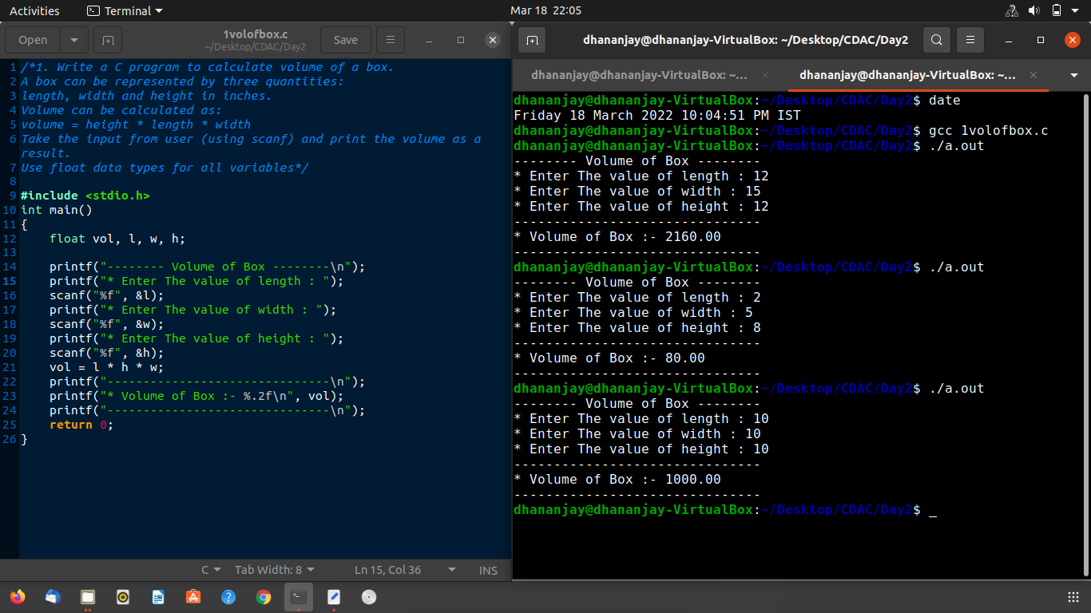

**Q2.**

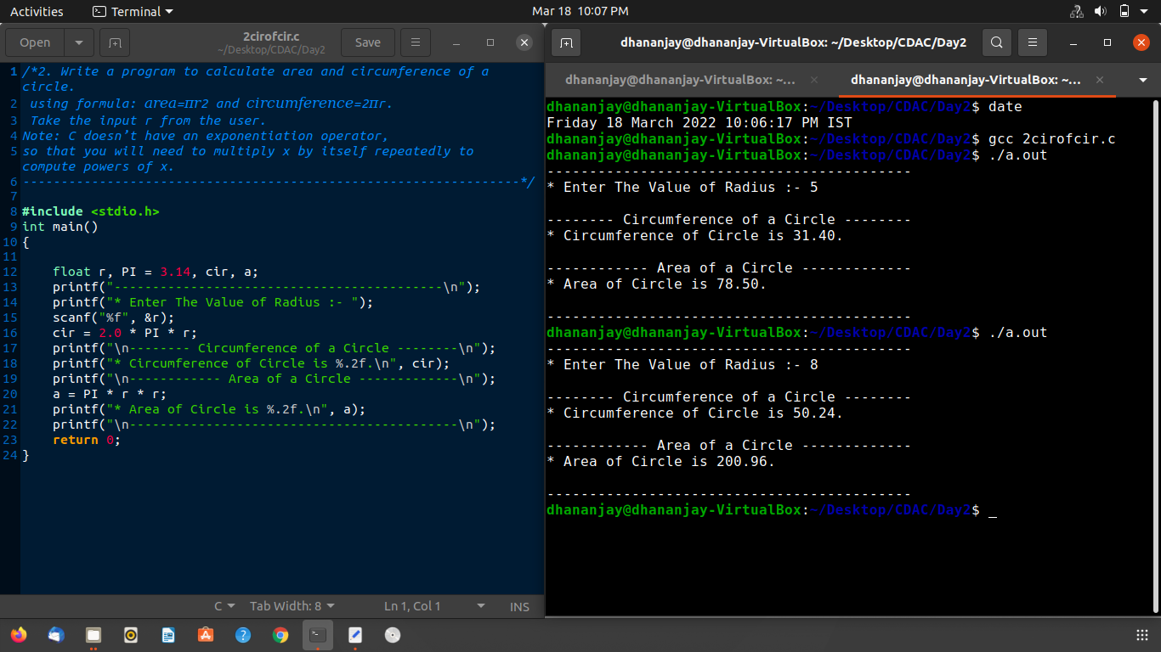

**Q3.** 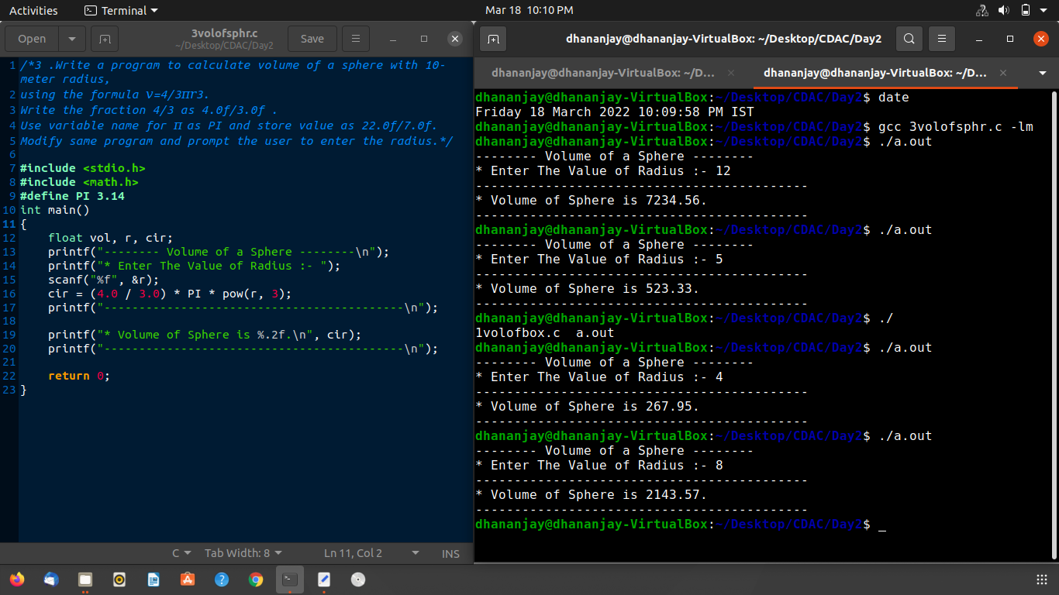

**Q4.**

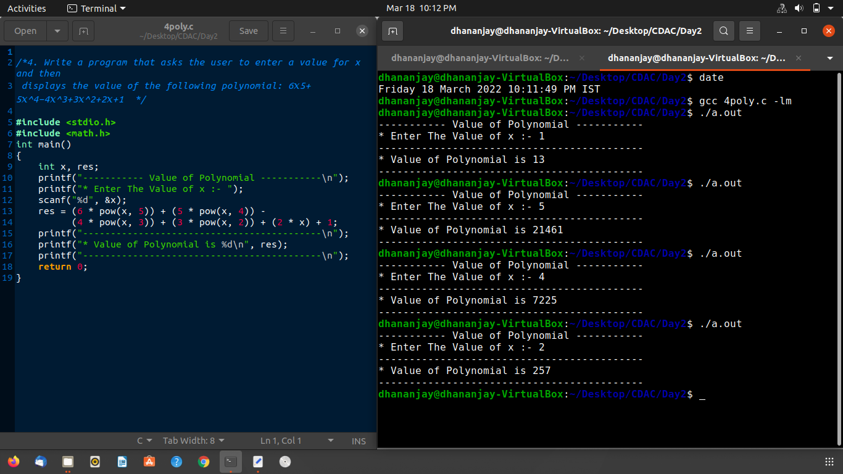

**Q5.**

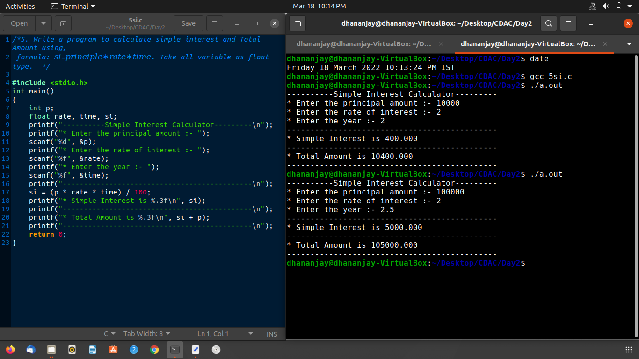

### **Day3:**

**Q1.**

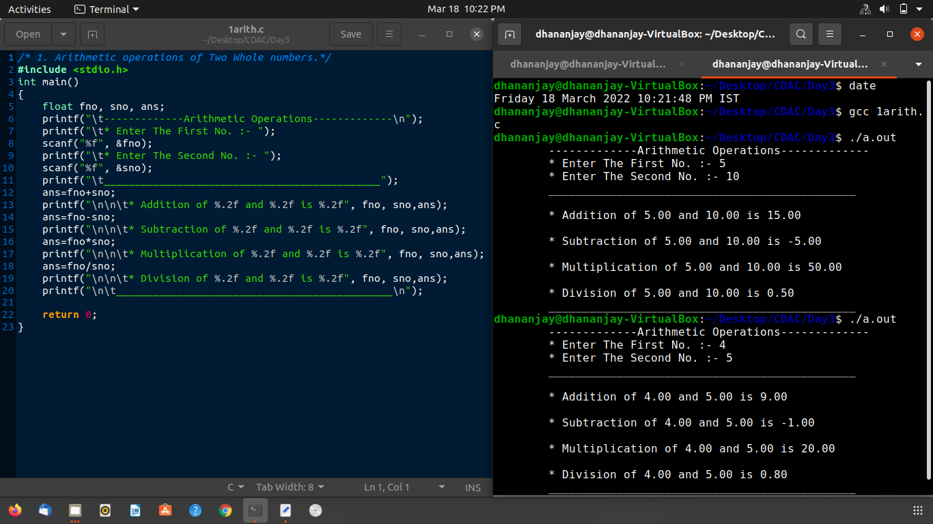

**Q2.**

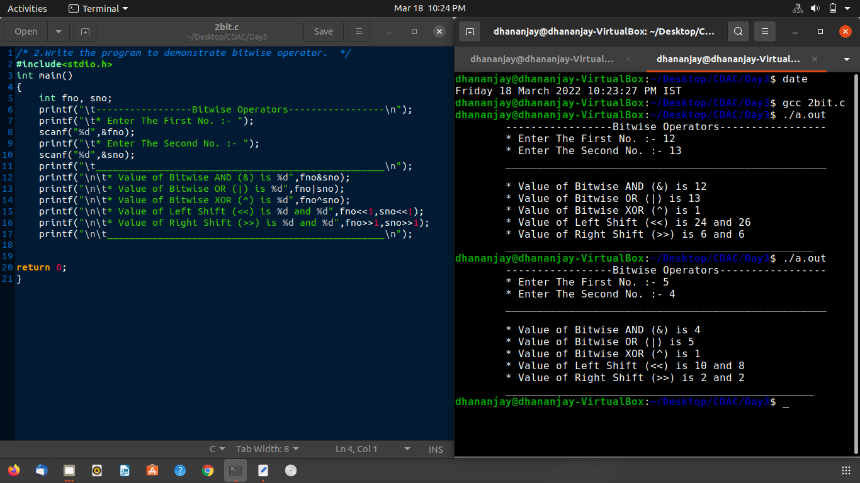

**Q3.**

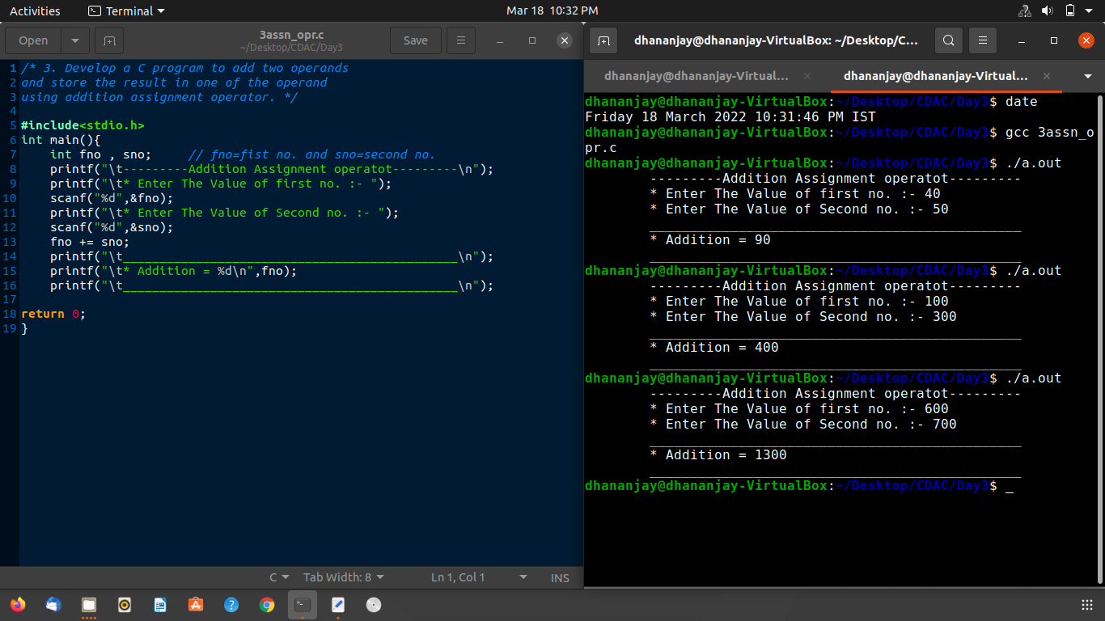

**Q4.**

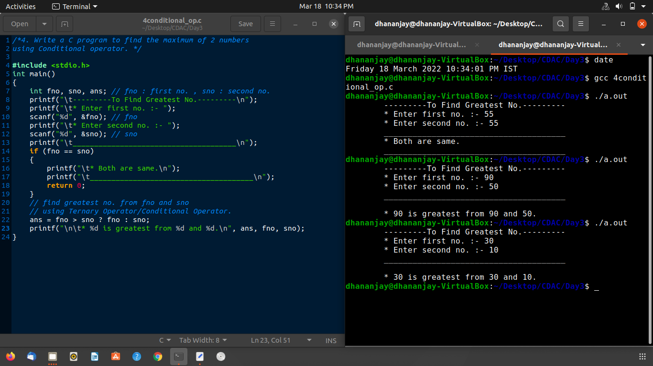

### **Day4:**

**Q1.**

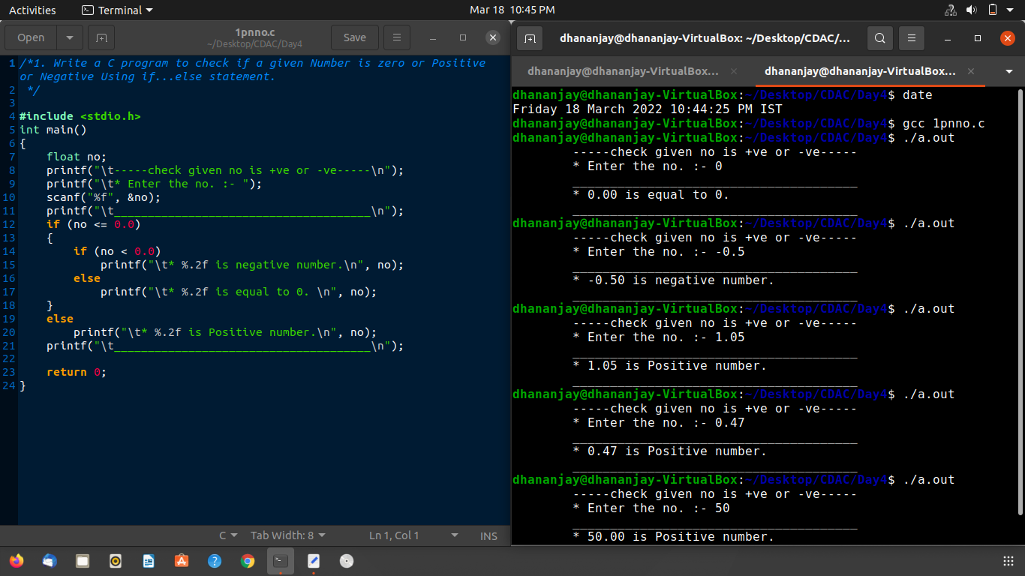

**Q2.**

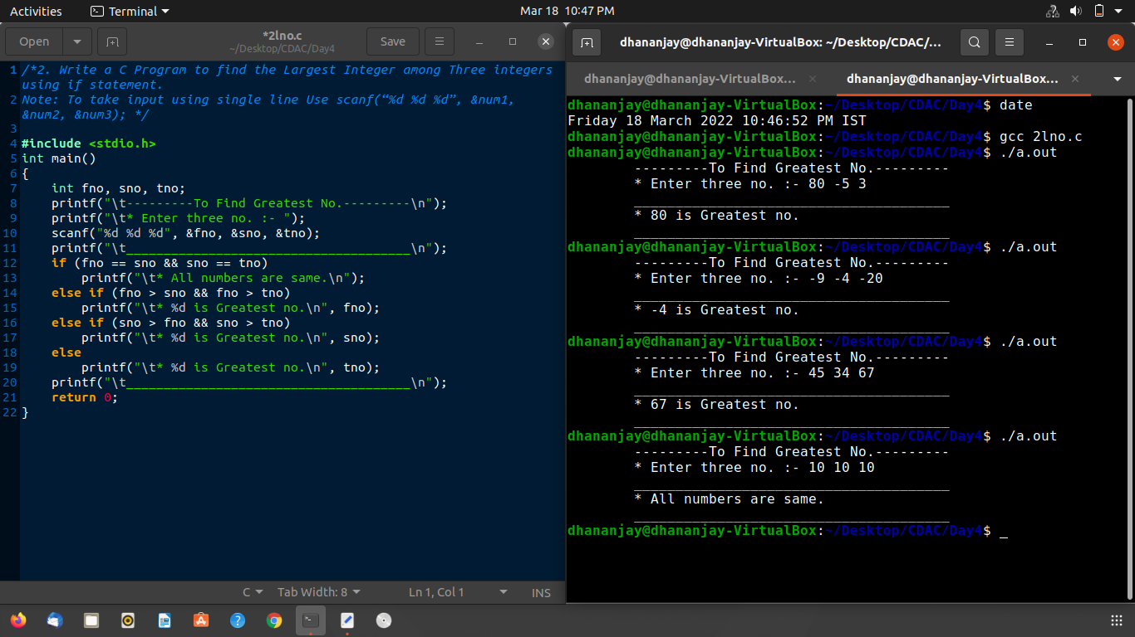

**Q3.**

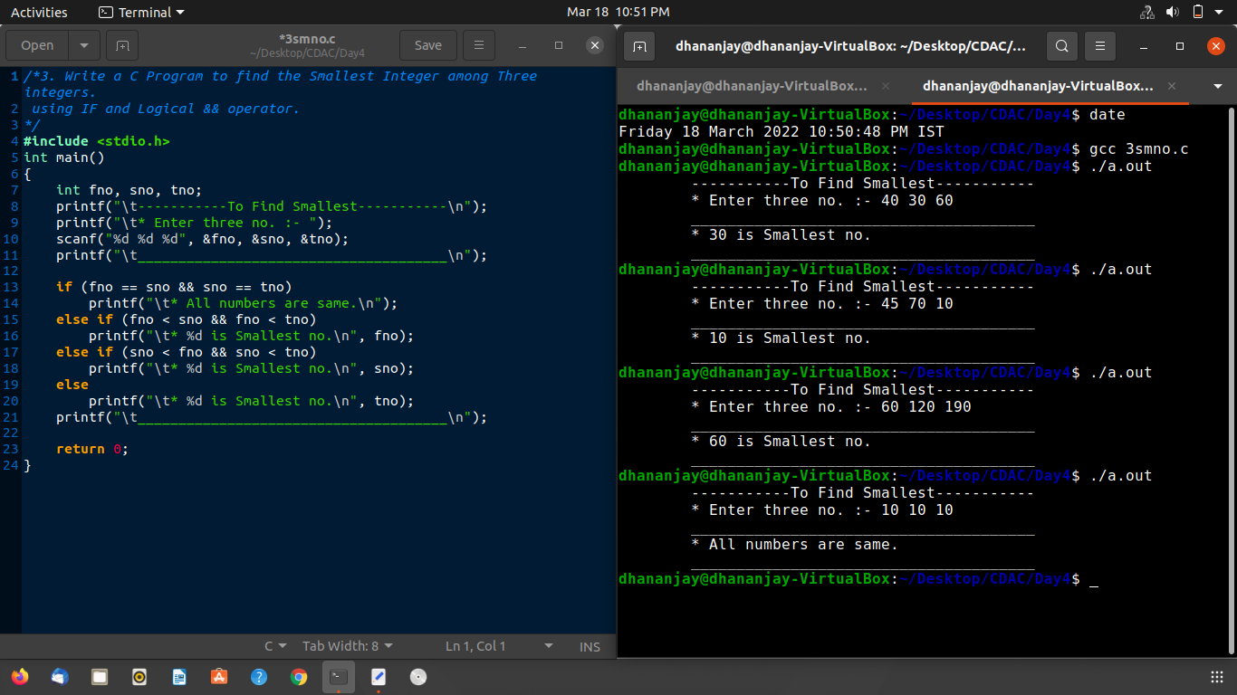

**Q4.** **What is output of following program?**



**Ans:- output will be CDAC0**

Because,in if statement Associativity of ‘ , ’ operator is left to right so i=3,due to value i=3 if condition is true then printf statement print “CDAC”. But precedence of ‘ = ’ operator is higher then ‘ , ‘ operator so ‘ i ’ become 0(zero)then after the if statement printf statement print ‘ 0 ’and **output become CDAC0.**

**Q5.**

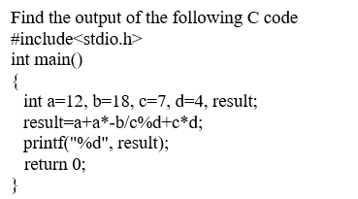

**Ans:- output will be 38.**

**Precedence of ( * / % ) is higher then (+ -) but Associativity is left-to-right.**

-> 12+(12*-18)/7%4+7*4

-> 12+(-216/7)%4+7*4

-> 12-(30%4)+(7*4)

-> 12-2+(7*4)

-> 12-2+28

-> **10+28 = 38.**

**Q6.**



**Ans:- output will be 11.**

**->** Z = y + ( y == 10);

**->** But y = 10; **->** Z = 10 + ( 10 == 10); **->** Z = 10 + 1; **->** **Z = 11**;

**Q7.**

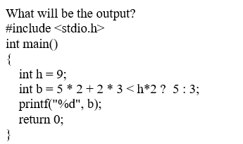

**Ans:- Output will be 5.**

h = 9;

b = ( 5*2 )+( 2*3)<(9*2)? 5 : 3;

b = 16 < 18 ? 5 : 3; // 16 < 18 True means return 1;

b = 1 ? 5 : 3;// if return 0 then b = 3;

**b = 5.**

**Q8.**



**Ans:- Output will be false.**

In if statement x++ is post increment then value of x is 0 means if statement not work.

But after if statement x++ become 1.therefore **output will be false**.

**Q9.**



**Ans:- Output will be false.**

Associativity of ‘ > ’ operator is left-to-right.

(c > b > a) 🡪 (0 > a) 🡪 0

If(0) means compiler goes to else and **else print false**.

**Q10.**



**Ans:- Output will be Delhi .**

d = ++a && ++b || c-- 🡪 associativity of && , || operator is left-to-right.

d= 1 && 0 || c-- ; 🡪 d = 0 || 0 🡪 d = 0. (c-- decrement after the statement ).

c = -1; 🡪 elseif statement true. Therefore **output become Delhi.**

### **Day5:**

**Q1.** 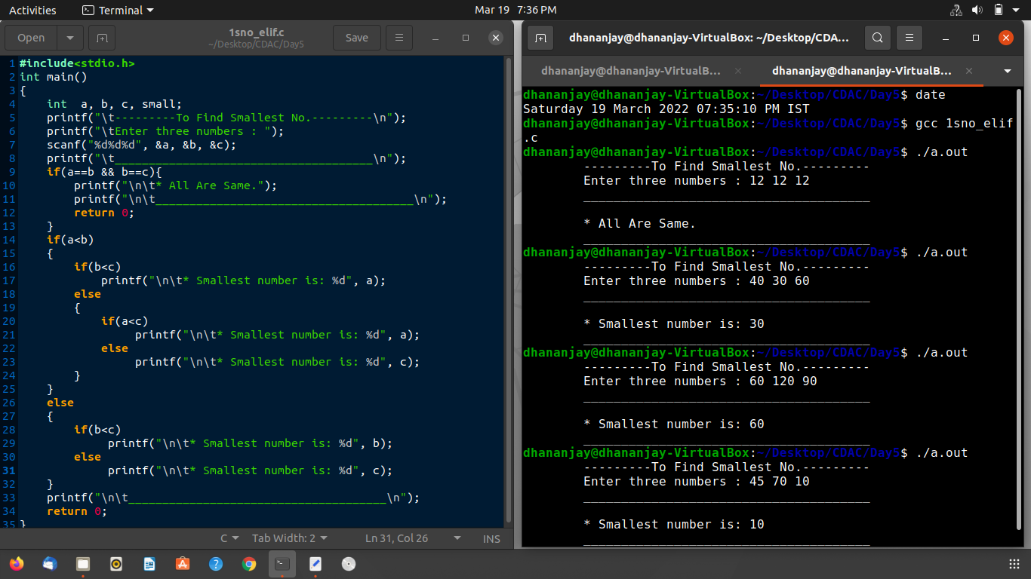

**Q2.**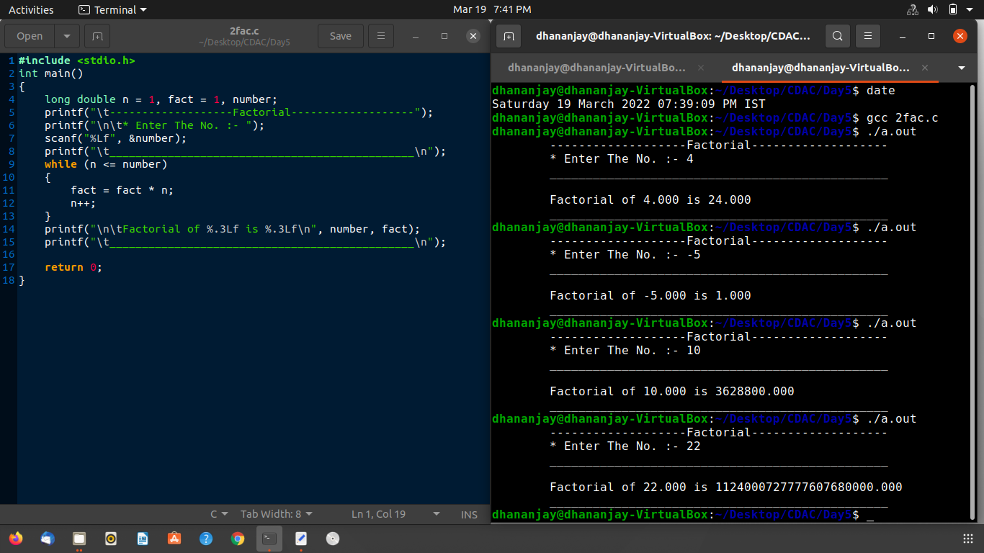

**Q3.**

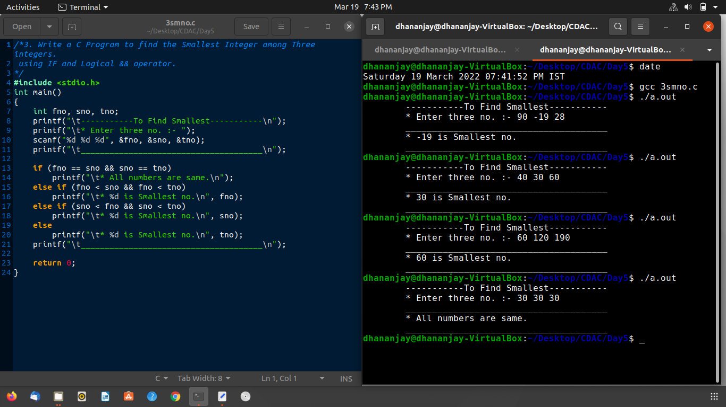

**Q4.**

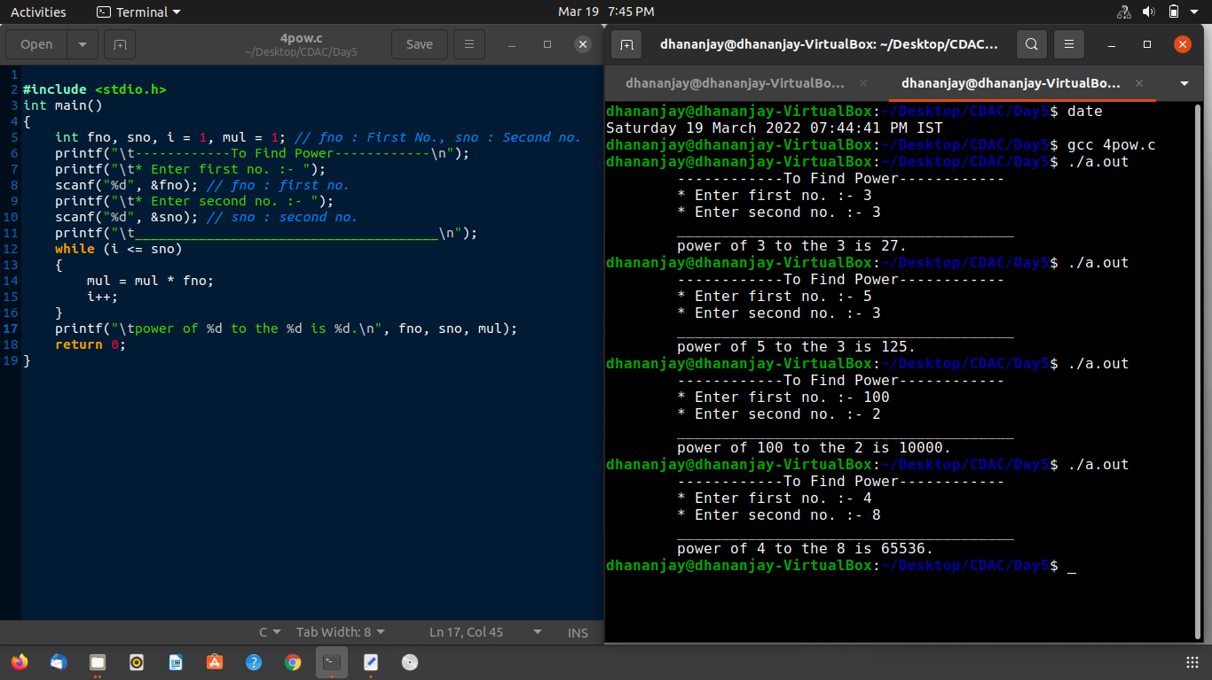

**Q5.**

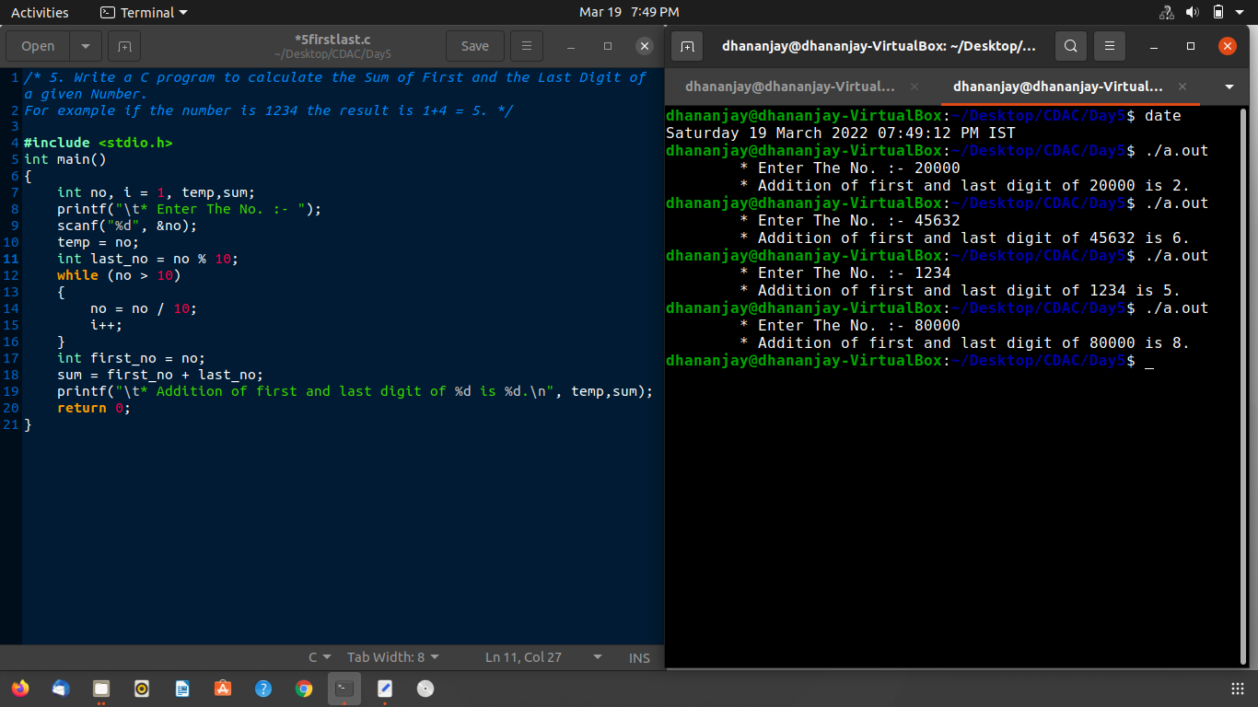

**Q6.**



**Ans :- the purpose of the given program is print reverse no.**

**Q7.**



**Ans:- Output will be**

**🡪Ture**

**🡪false**

Because value of a = 1;

Condition of if statement is a—but post decrement means value decrese after

statement.so if condition is True then it print ‘ True ’.after the if statement value of

a = 0 but second if condition is ++a it is pre increment so value of a again become 1 and condition is true then it print ‘ false ’ new line.

**Q8.**

**Ans:- Output will be 0.00**

Because, data type of p , t , si is int not float.

**Q9.**



**Ans:- Output will be 65.**

Because, 0101 is octal number.first it convert into decimal and then print the value 65.

**Q10.**



**Ans:- Output will be 5 7.**

Because, initially value of ver1 is 10 but in if condition it become a 5.

And in if statement var2 is increment by 1. So var2 become 7.

**Q11.**



**Ans:- Output Will be**

**0**

**1 1**

**Solution:**

i++ && ++j 🡪 0++ && ++j 🡪 0 (due to post increment i = 0 into the statement)

in second printf I become 1 and j = 1 in previous statement.

**Q12.**

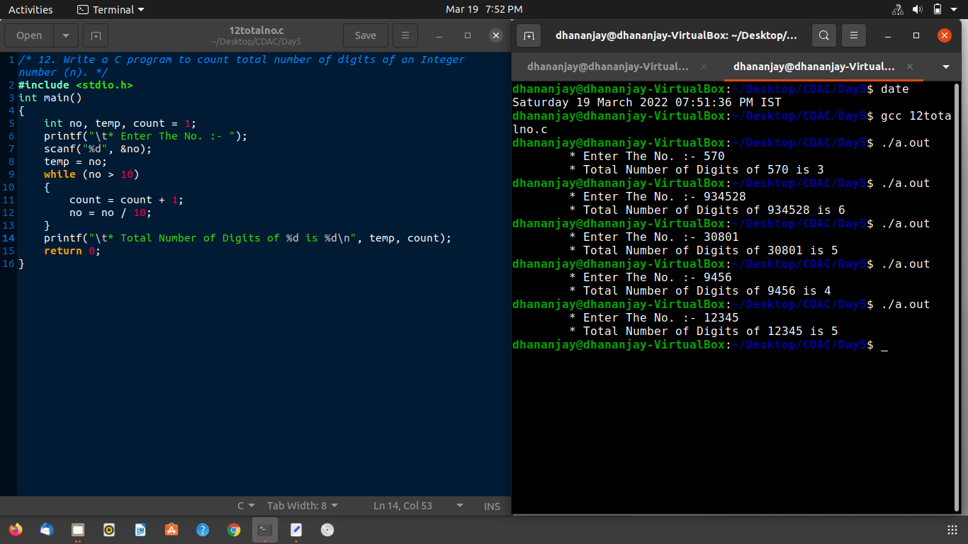

**Q13.**

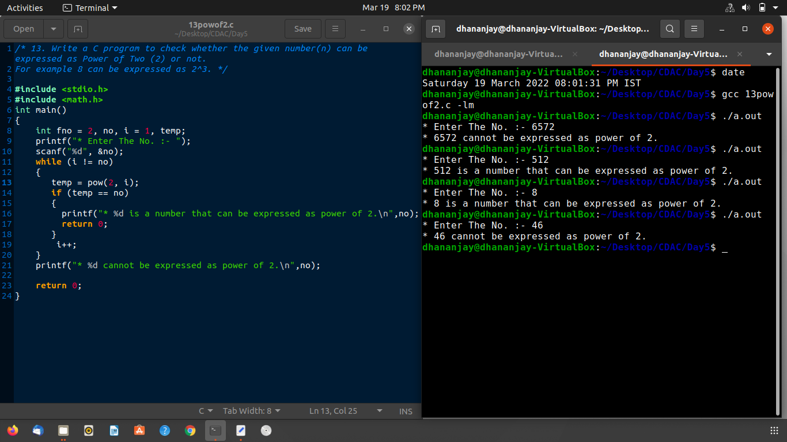

**Q14.**

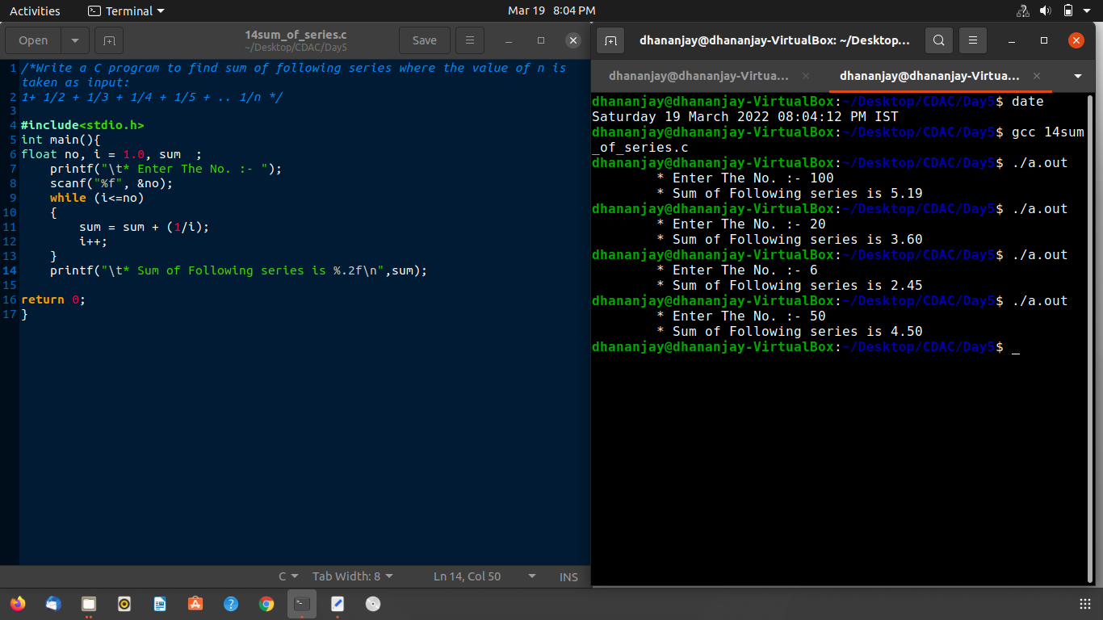

**Q15.**

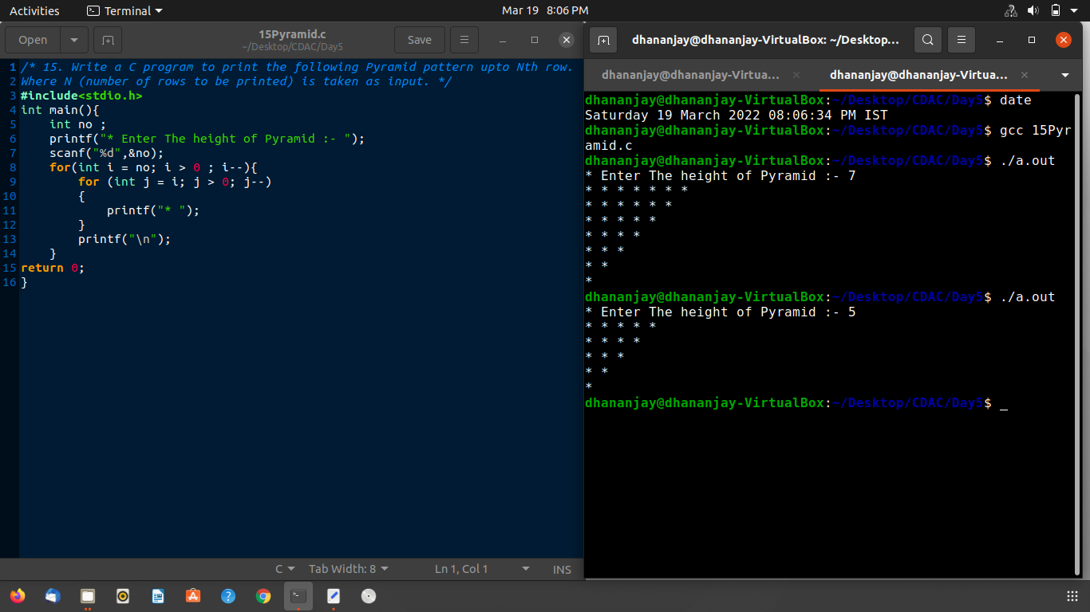

**Q16.**

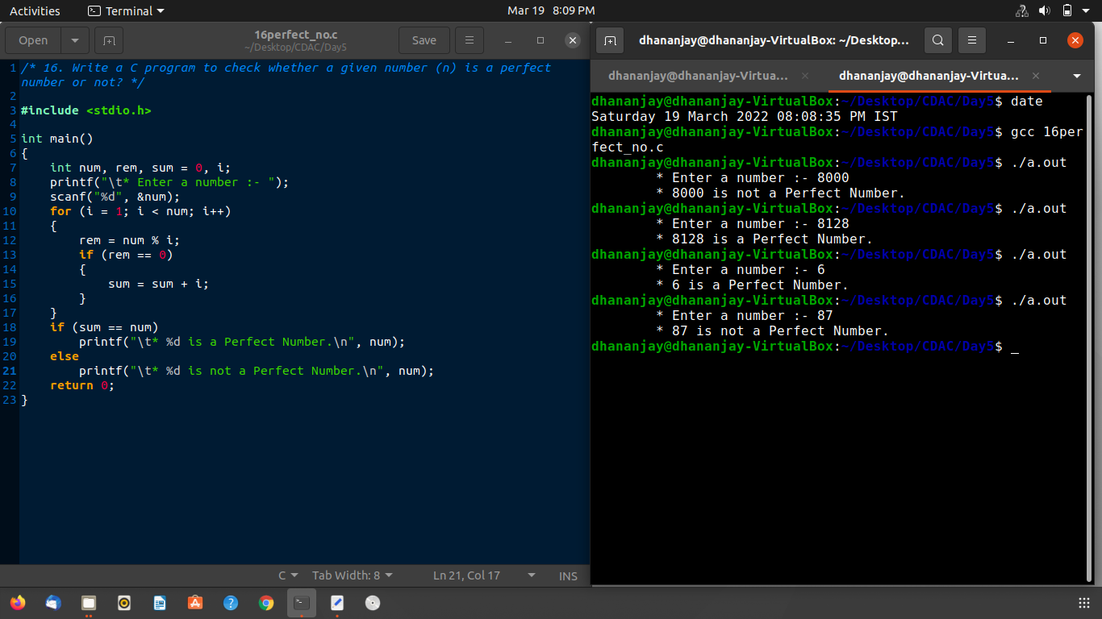

**Q17.**

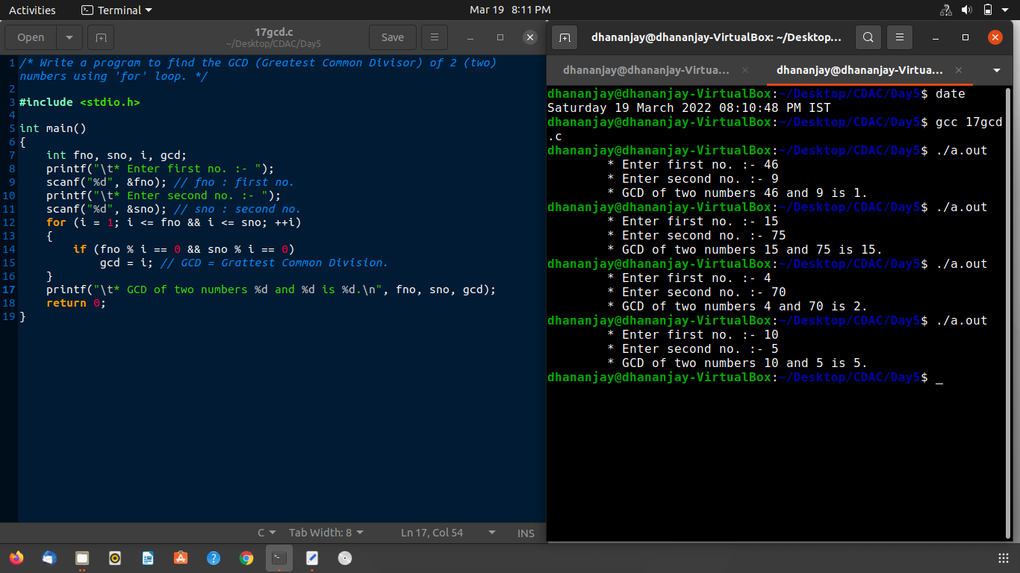

### **Day6:**

**Q1.**

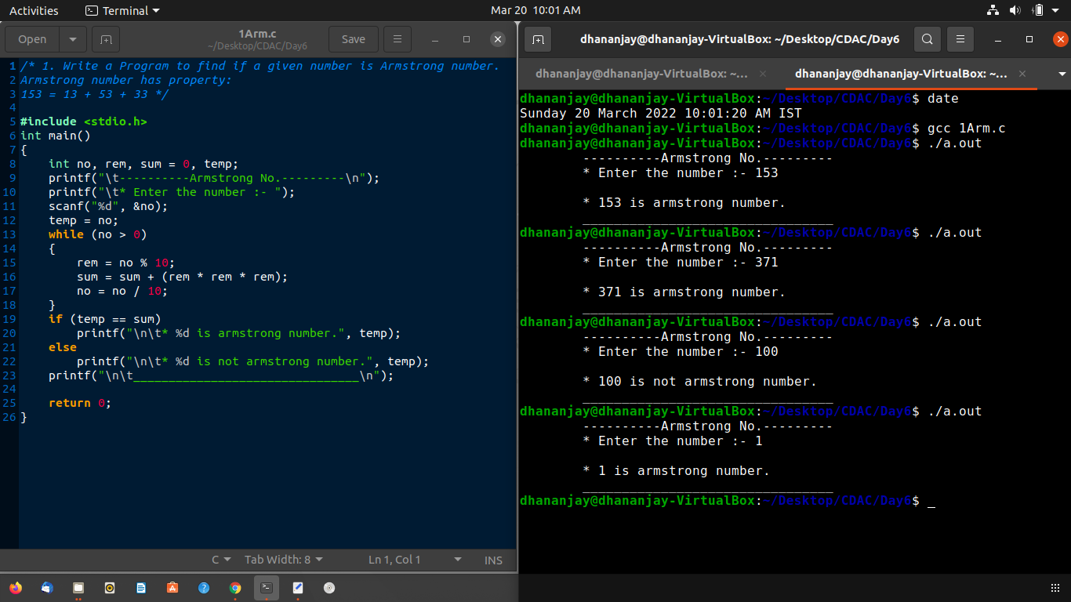**Q2.**

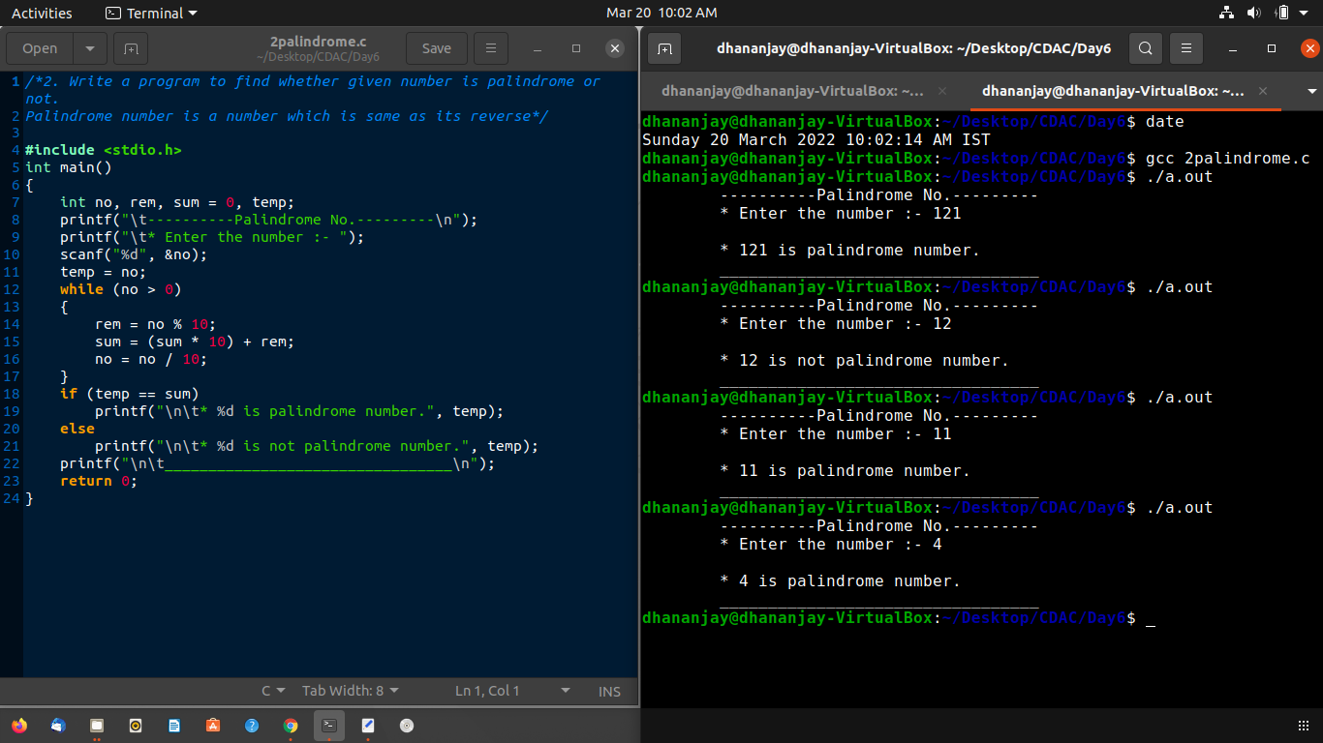

**Q3.**

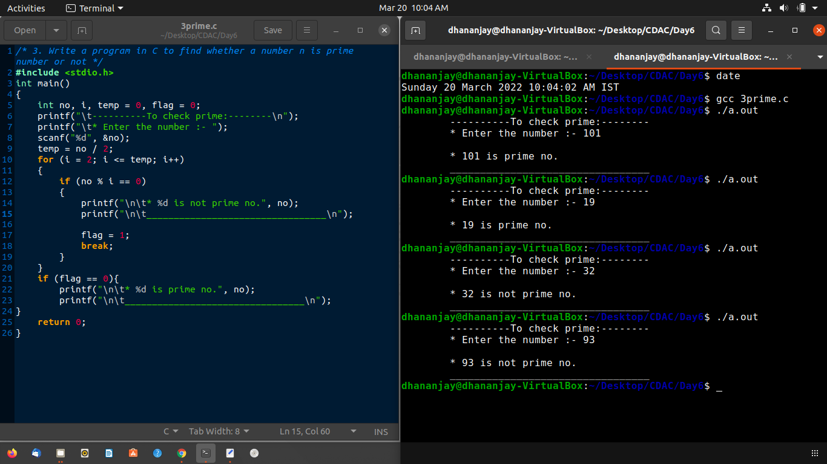

**Q4.**

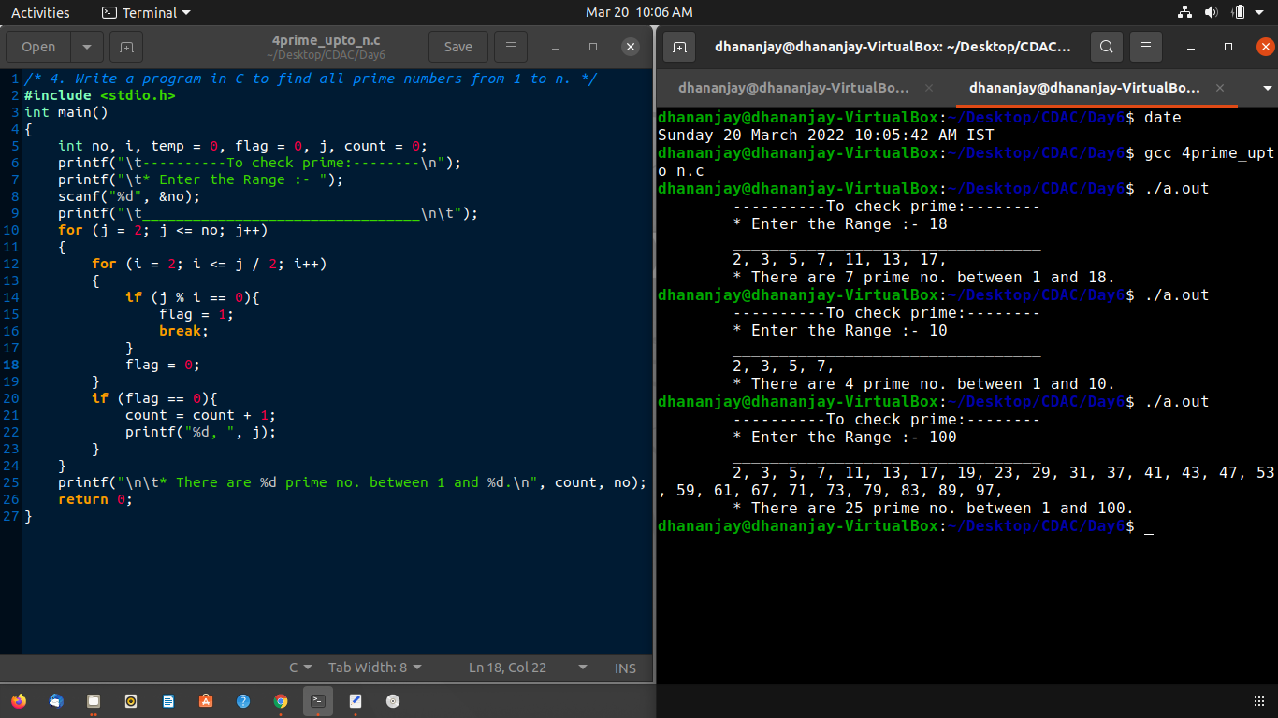

**Q5.**



**Ans:- Output will be 4.**

Because The continue statement breaks one iteration (in the loop), if a specified condition occurs, and continues with the next iteration in the loop.

**Q6.**



**Ans:- Output will be i=5, j=5, k=2.**

j=++arr[2]; 🡪 j = 3 + 1; 🡪 j = 4; 🡪 but in i = arr[j++] **‘ j ’ become 5.**

k = arr[1]++; 🡪**k =** **2 (due to post increment).**

i = arr[j++] ; 🡪 i = arr[4] 🡪 **i = 5.**

**Q7.**



**Ans:- Output will be IIT MADRAS.**

Because sizeof(a) is 24. There is no case in switch. Then compiler jump in printf(“IIT MADRAS”); this statement is executed.

**Q8.**



**Ans:- ‘a‘ will be print 5 times.**

Because while loop will execute 5 time (0 to 4) and printf(“a\n”) after while loop.

**Q9.**



**Ans:- Output will be 4,4.** Because arr[1] = ++arr[1]; 🡪 arr[1] = 3;

a = arr[1]++; 🡪 **a = 4 ;**

arr[1] = arr[a++]; 🡪 arr[4]; 🡪 **arr[1] = 4;**

**Q10.**

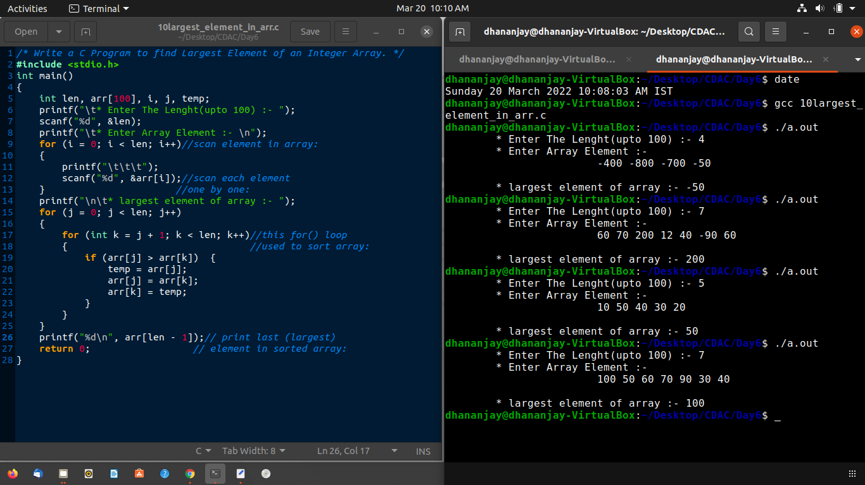

**Q11.**

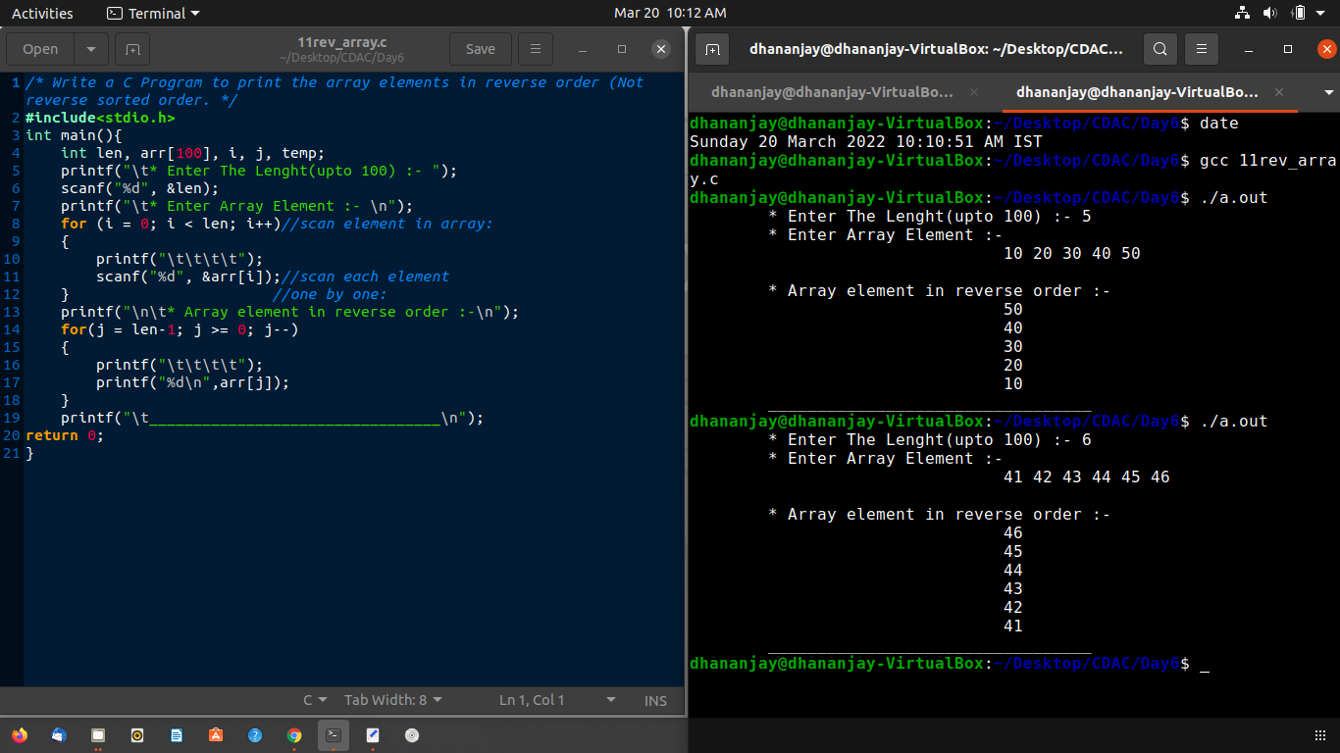

**Q12.**

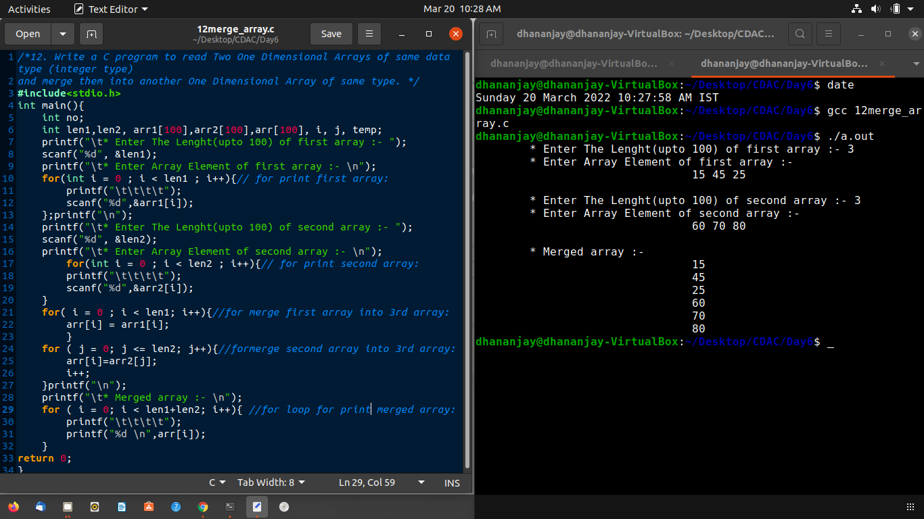

**Q13.**

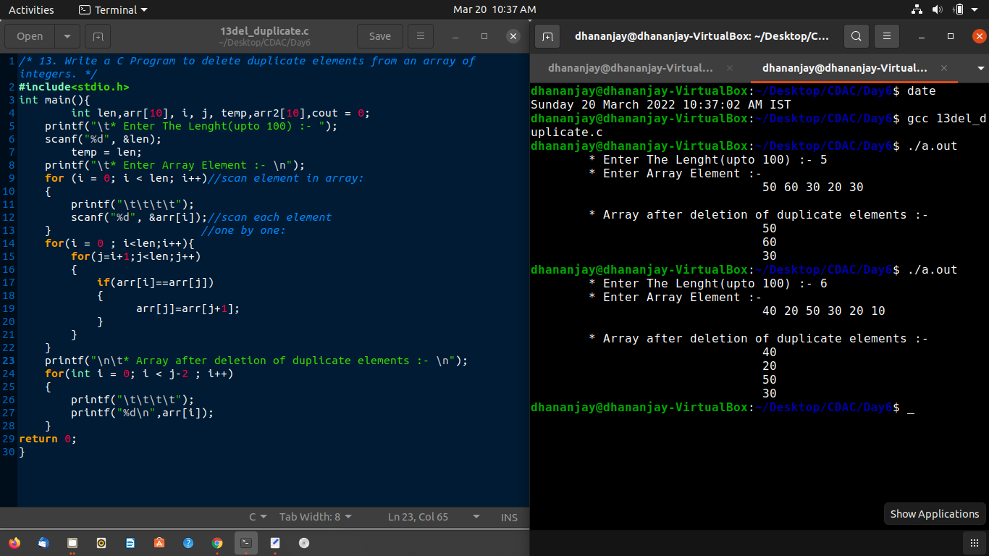

**Q14.**

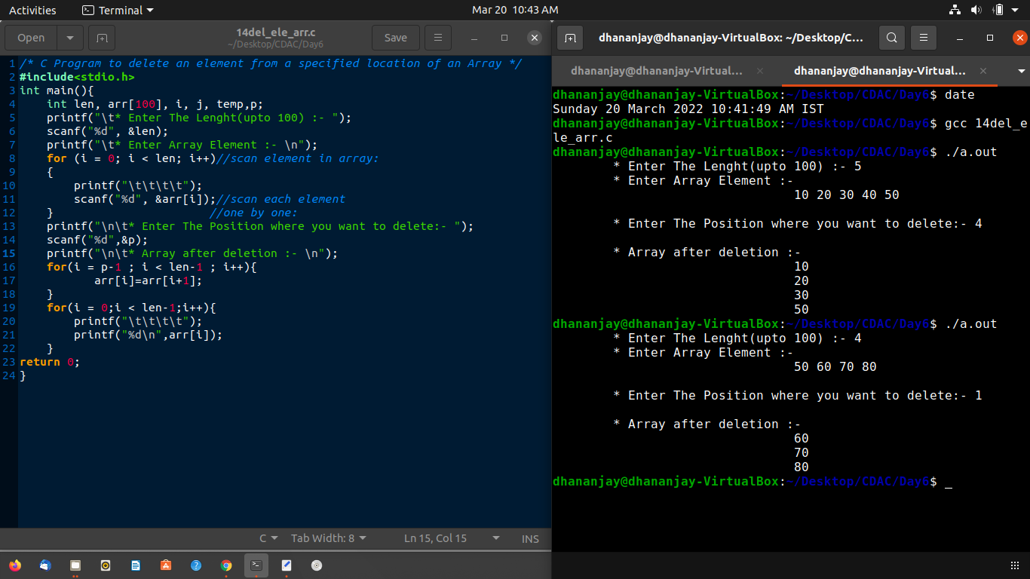

**Q15.**

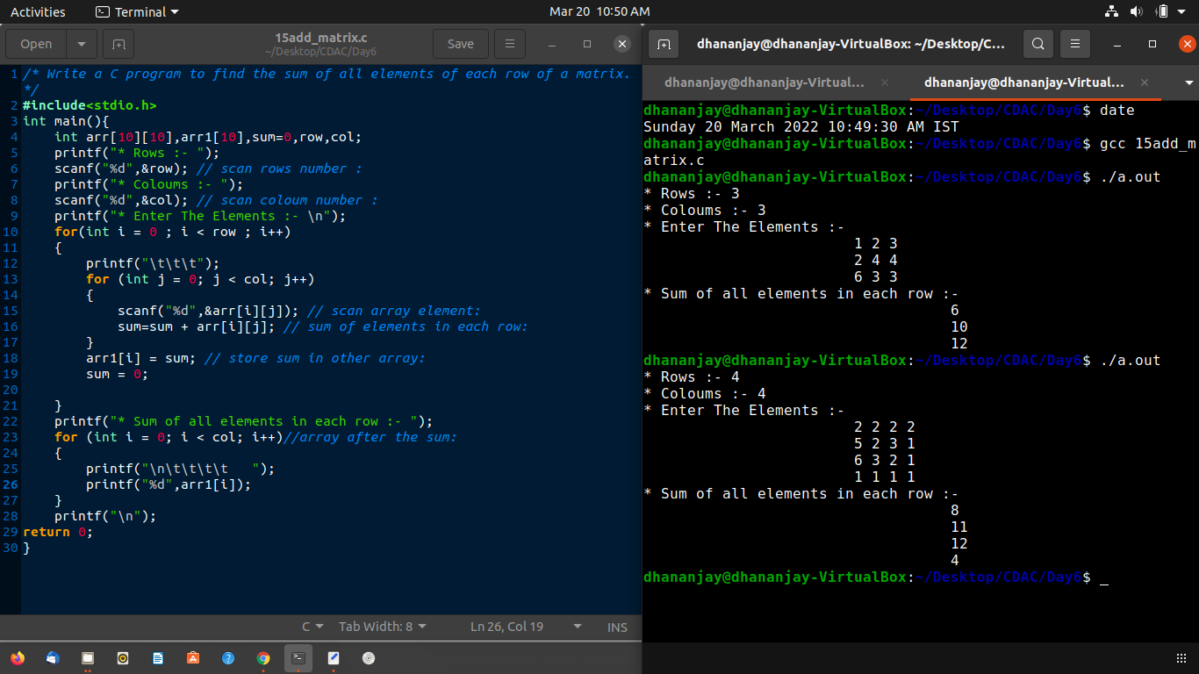

**Q16.**

/*16. Write a C program to find subtraction of two matrices

i.e. matrix_A -matrix_B=matrix_C. */

    #include<stdio.h>

    int main(){

        int arr1[10][10],arr2[10][10],arr3[10][10],sum=0,row,col;

    printf("* Rows :- ");

    scanf("%d",&row);

    printf("* Coloums :- ");

    scanf("%d",&col);

    printf("* Enter The Elements in first matrix :- \n");

    for(int i = 0 ; i < row ; i++)

    {

        printf("\t\t\t");

        for (int j = 0; j < col; j++)

        {

            scanf("%d",&arr1[i][j]);

}

    }

    printf("* Enter The Elements in first matrix :- \n");

        for(int i = 0 ; i < row ; i++)

    {

        printf("\t\t\t");

        for (int j = 0; j < col; j++)

        {

            scanf("%d",&arr2[i][j]);

        }

    }

    printf("* After subtraction:- \n");

    for(int i = 0 ; i < row ; i++)

    {

        for (int j = 0; j < col; j++)

        {

            arr3[i][j]=arr1[i][j] - arr2[i][j];

        }

    }

    for (int i = 0; i < row; i++)//for loop for print subtracted matrix:

    {

        printf("\t\t");

        for (int j = 0; j < col; j++)

        {

            if(arr3[i][j]<0){

               printf("%d ",arr3[i][j]);

               continue;

            }

            printf(" %d ",arr3[i][j]);

        }

        printf("\n");

    }

    return 0;

    }

**Output:**

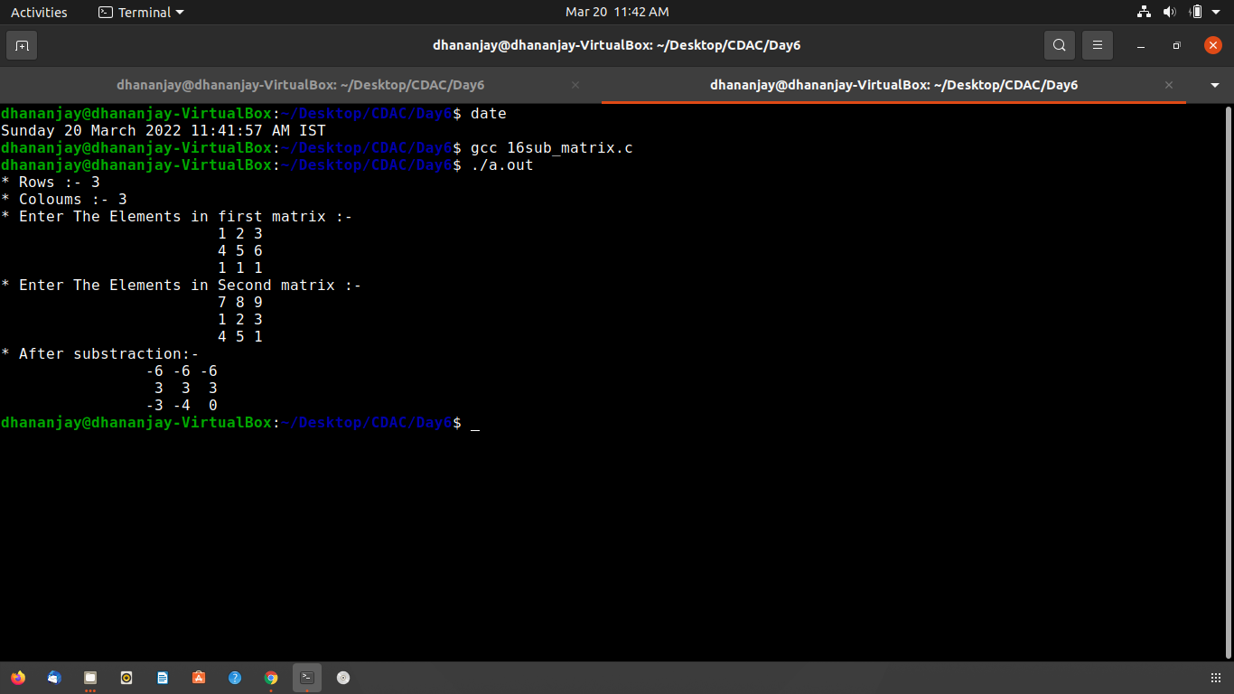

**Q17.**

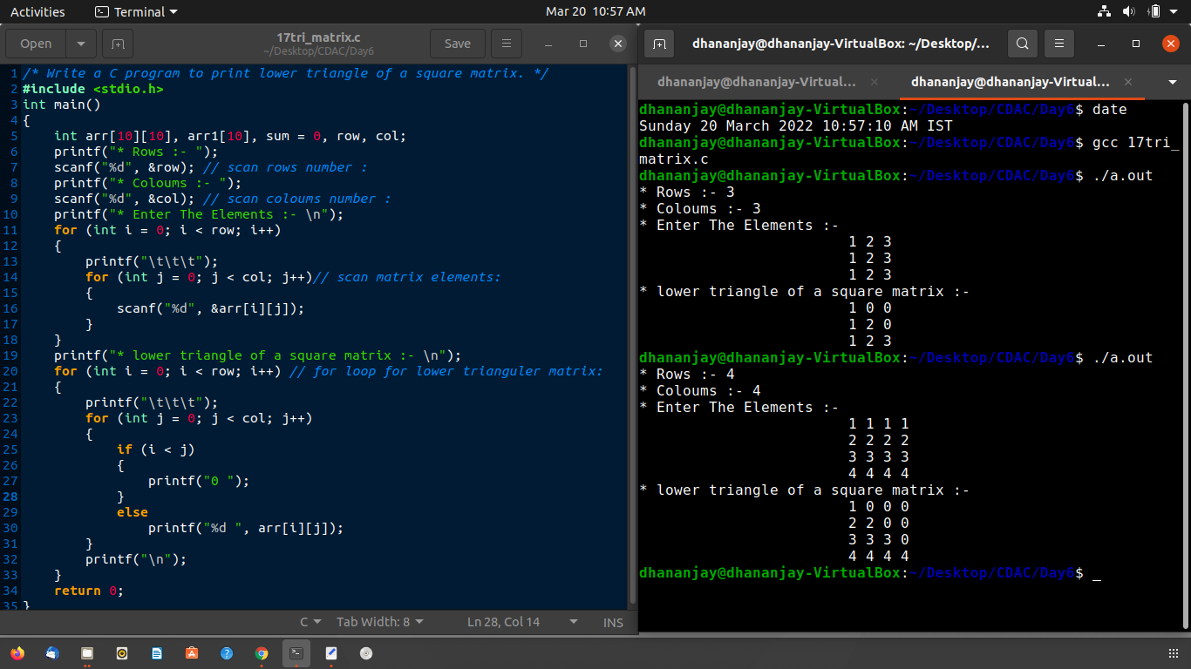

### **Day7:**

**Q1.**

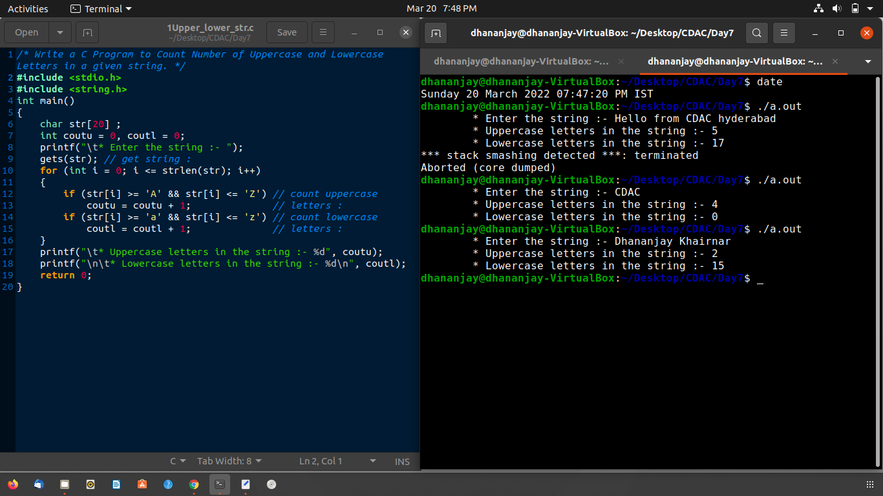

**Q2.**

/* Write a C program to print Largest and Smallest Word from a given sentence.*/

#include <stdio.h>

#include <string.h>

int main()

{

    char words[100][100], small[100], large[100], str[100];

    int i = 0, j = 0, k, length;

    printf("\t* Enter the string :- ");

    gets(str); // get string :

    for (k = 0; str[k] != '\0'; k++)

    {

        if (str[k] != ' ' && str[k] != '\0')

        {

            words[i][j++] = str[k];

        }

        else

        {

            words[i][j] = '\0';

            // Increment row

            i++;

            j = 0;

        }

    }

    length = i + 1;

    strcpy(small, words[0]);

    strcpy(large, words[0]);

    for (k = 0; k < length; k++)

    {

        if (strlen(small) > strlen(words[k]))

            strcpy(small, words[k]);

        if (strlen(large) < strlen(words[k]))

            strcpy(large, words[k]);

    }

    printf("\t* Smallest word from sentence:- %s\n", small);

    printf("\t* Largest word from sentence:- %s", large);

    return 0;

}

**Output:**

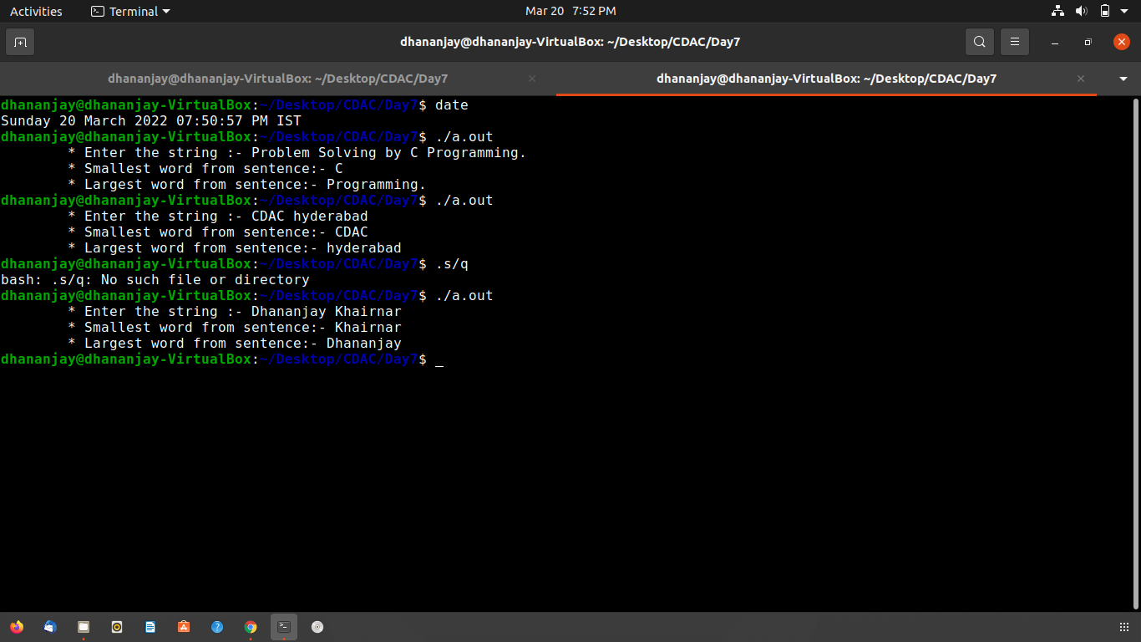

**Q3.**

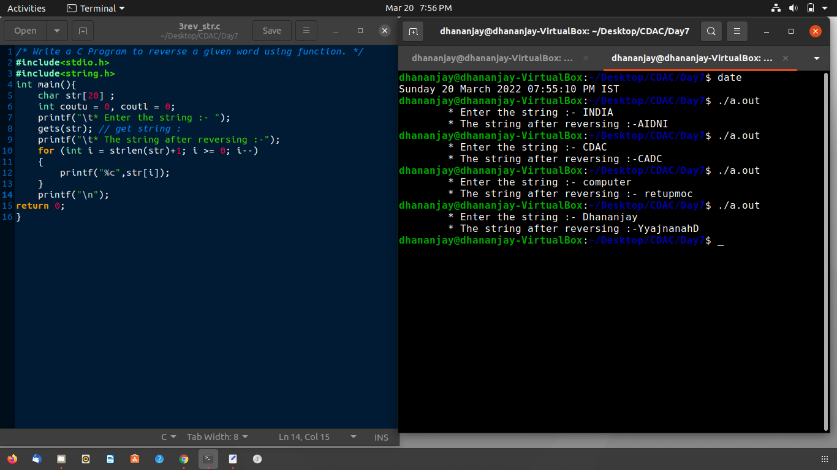

**Q4.**

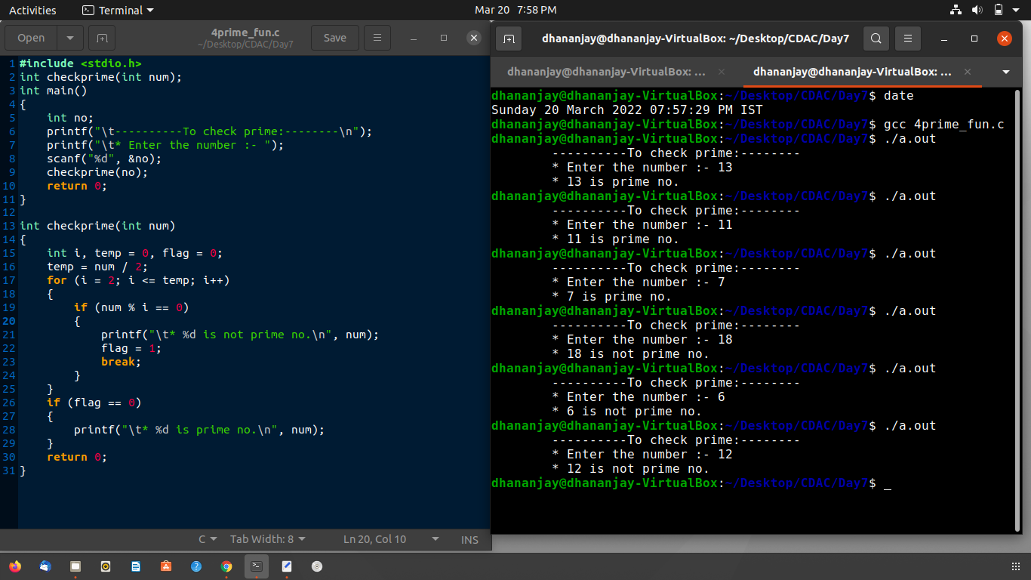

**Q5.**

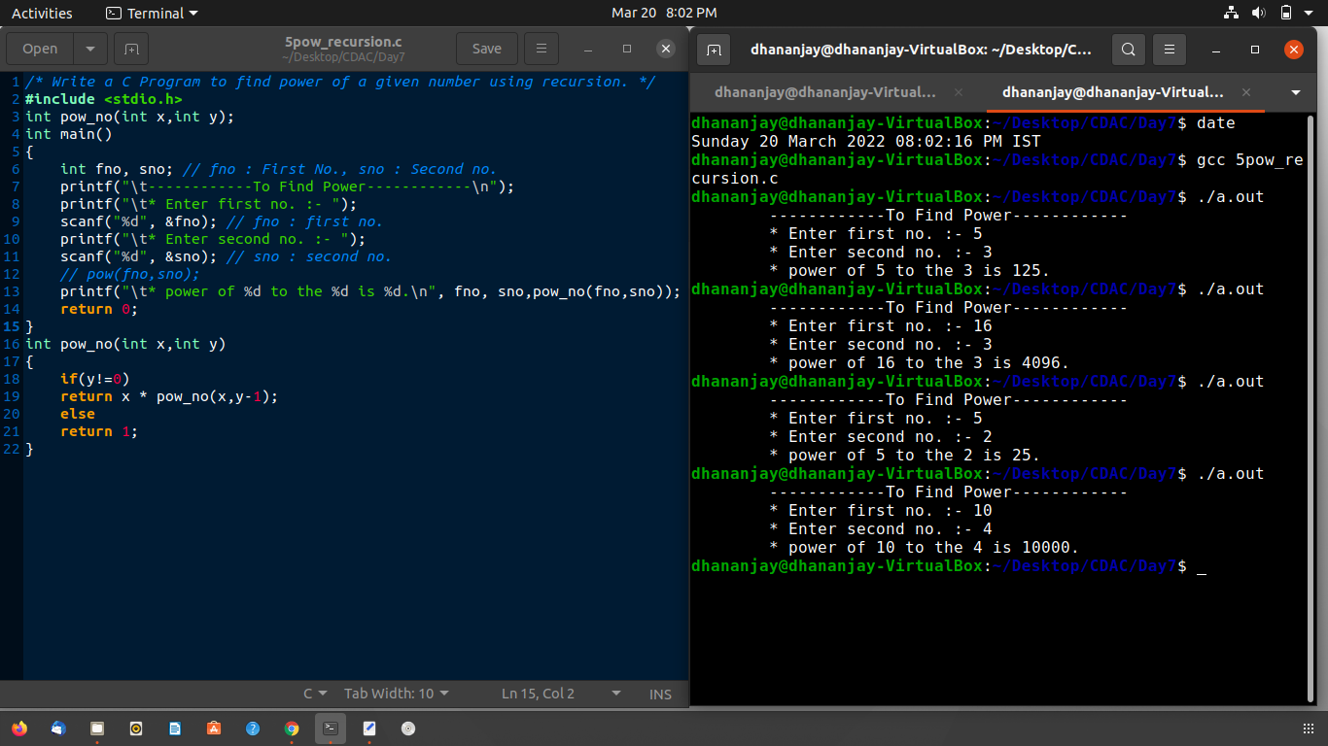

**Q6**

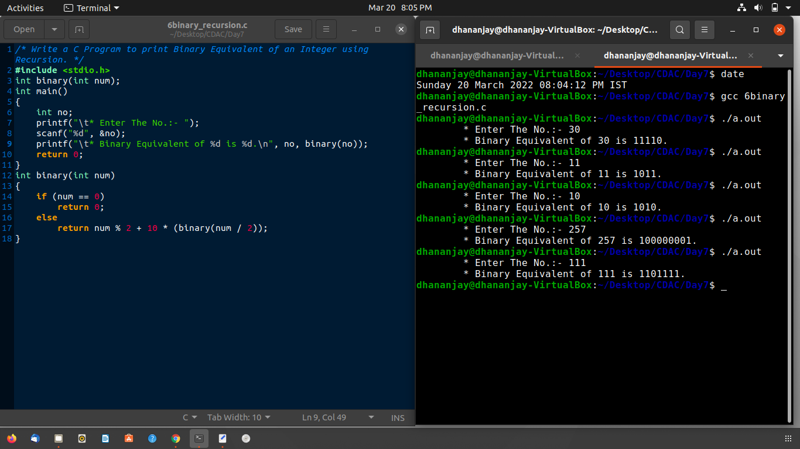

**Q7.**



**Ans:- Output will be n1=18, n2=18;**

sizeof(str1) = 18 (including NULL char) 🡪 n1 = 18/1 🡪 **n1 = 18.**

sizeof(str2) = 18 (including Null char) 🡪 n2 = 18/1 🡪 **n2 = 18.**

**Q8.**



**Ans:- Output Will be hello world**

**strcat** it is a function that appends the string pointed to by source to the end of the string pointed to bt destination.so str2 append the **str1 it will be hello world.**

**strcpy** it is a function copy string from source to destination means strcat() is source and str2 is destination.so hello world is copy into str2.then **str2 = “hello world“.**

**Q9.**



**Ans:- To print “ Hwi orea ” we need take if(i%2==0).**

**Q10.**



**Ans:- Value of i after the execution is 0. strcpy** is function that copy string from source to destination string. then str1 copy in str2 means str2 become “ dills ”and **strcat**  is function that append source to destination. means str3 is daffodils. **strcmp** is function that compares each character of source string and destination string. means **str3 compres with “ daffodils ” both are same therefore its return 0.**

**Q11.**



**Ans:- Output will be “ tnemngissa ”(reverse of string)**

**Q12.**



**Ans:- Output Will be 67,99.**

because actual argument of y is char is ‘ c ’but it in function decleration formal argument is int. so character ‘ c ’ is convert into int by ASCII value then ASCII Value of ‘ c ’ is 99 therefore it print 99.

**Q13.**



**Ans:- function call f(1) return 7.**

**Q14.**



**Ans:- “ Hi ” will be print 0 times.**

because default value of is 0. so while loop is not executed and function can’t called.

**Q15.**



**Ans:- Output will be 27.08.(Average of age);**

pointer of age passed to function as formal argument and for loop calculate sum of all ages.result calculate average of age and return float result value to function call.

**Q16.**

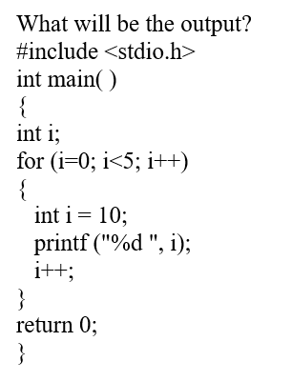

**Ans:- Output will be 10 10 10 10 10.**

because for loop execute 5 times (0 to 5)

and i is redeclear and initialize in for loop as 10.

**Q17.**



**Ans:- Function Factorial will be executed 11 time.(due to function recursion)**

* **function factorial call itself 11 times.**

**Q18.**



**Ans:- Output will be**

**“ Before swapping num1 = 10 num2 = 20 “**

**“ After swapping num2 = 10 num2 = 20 ”**

because function swap() call by value it can not changed actual arguments. but if we used to call swap() function by call by reference it will be swaping or change the value.

**Q19.**



Q.The function func() is used to find…?

**Ans:- Function of func() is return middle number from three.**

### **Day8**

**Q1.** 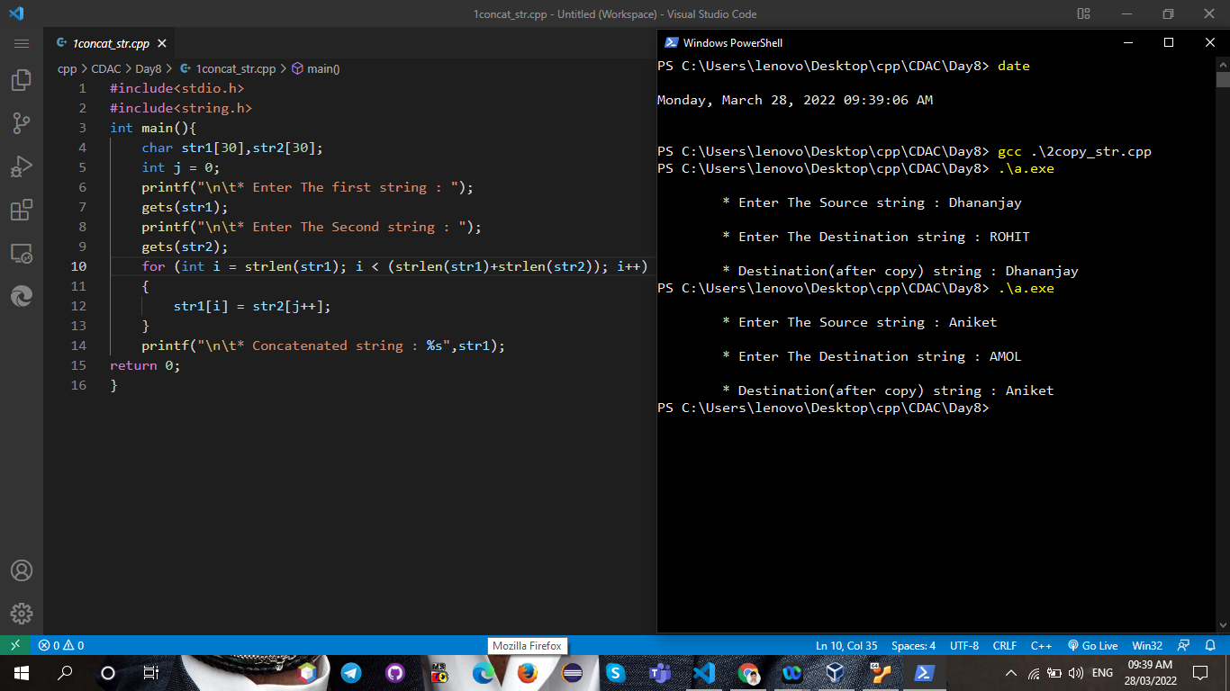

**Q2.**

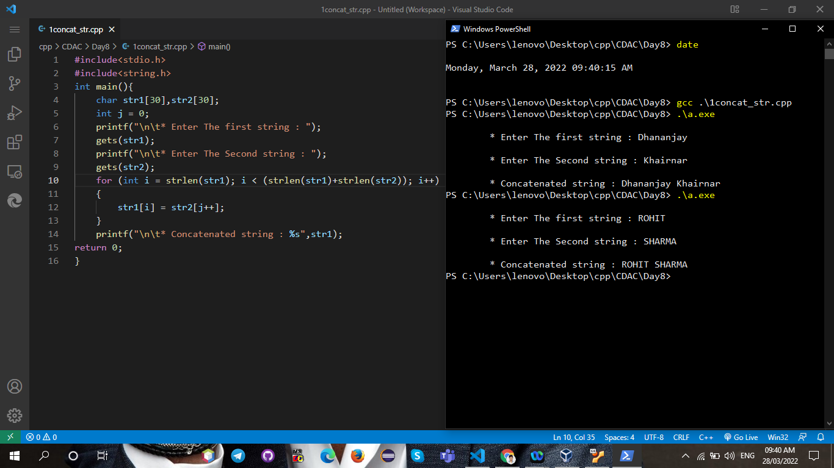

**Q3.**

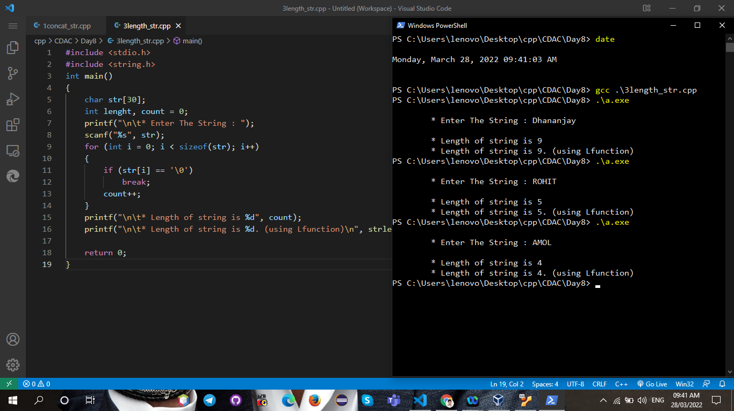

### **Day9**

**Q1.**

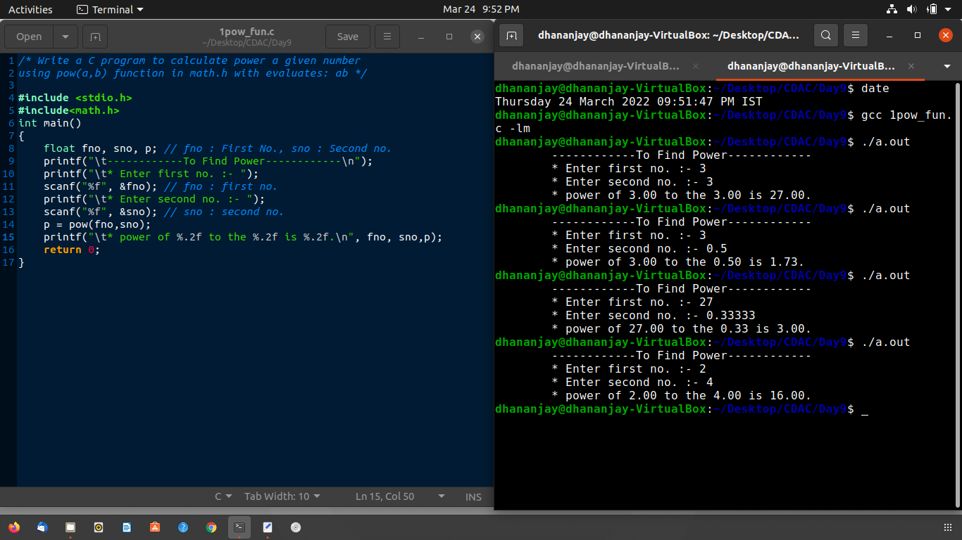

**Q2.**

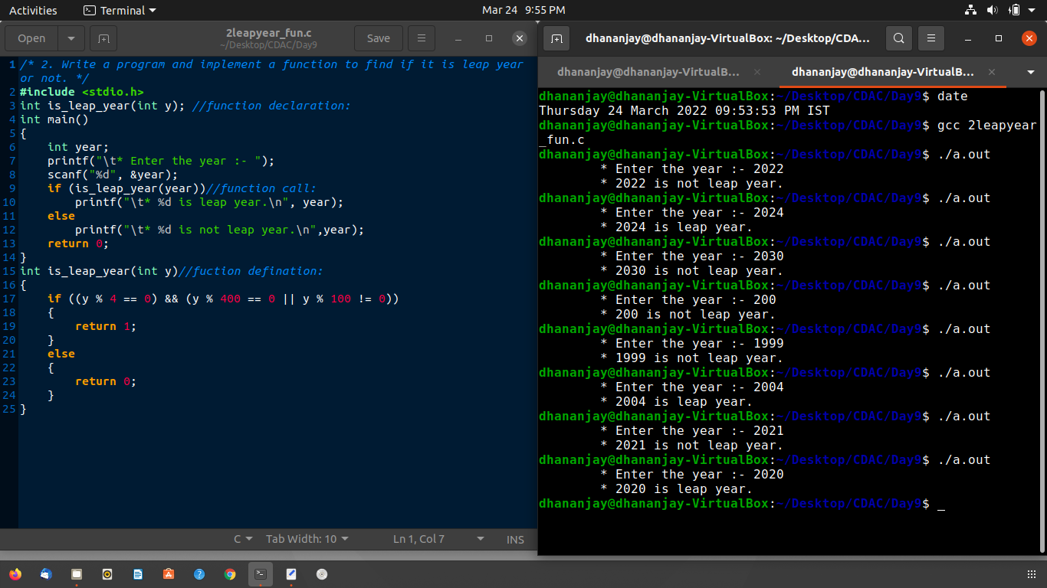

**Q3.**

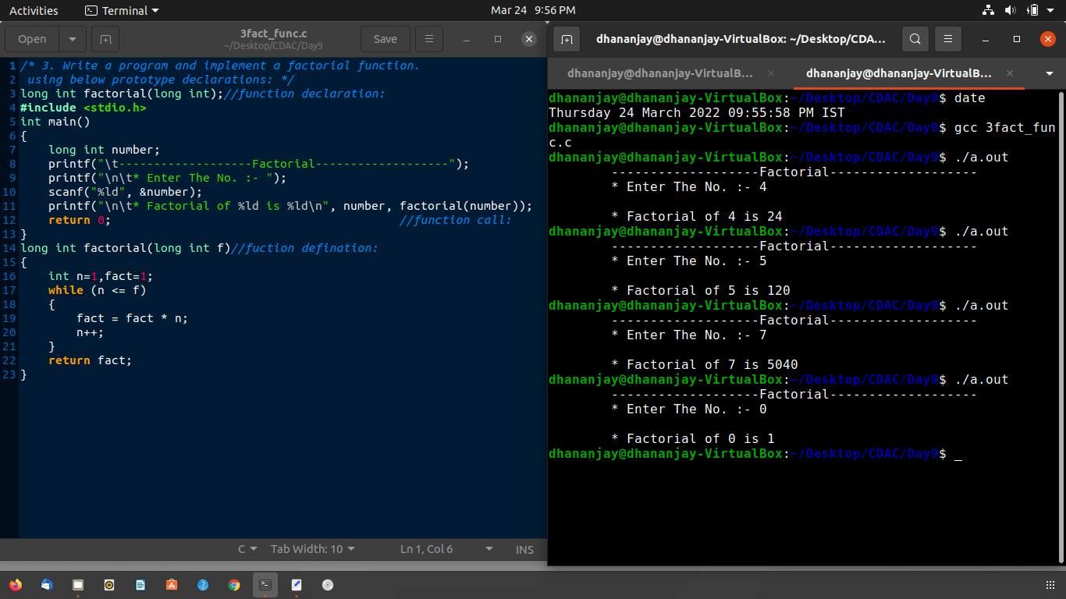

**Q4.**

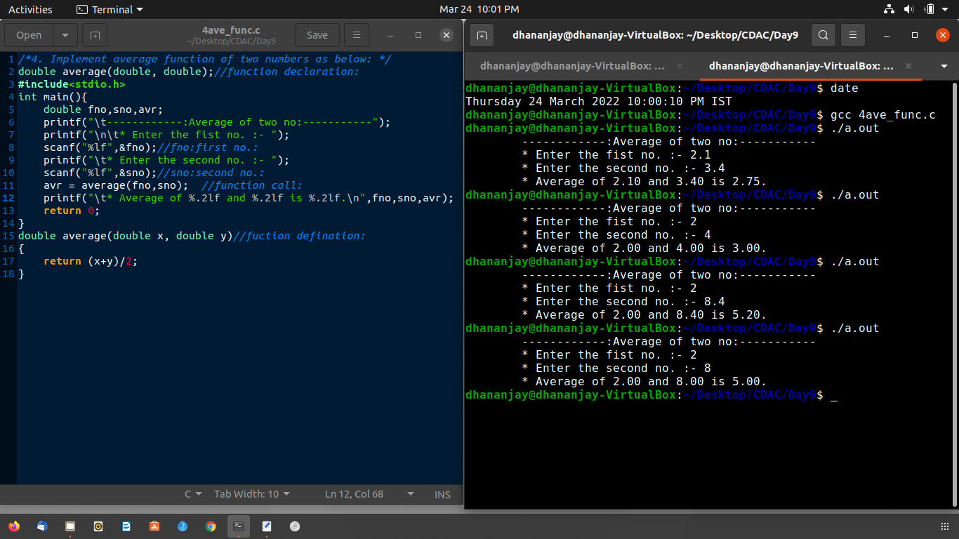

**Q5**

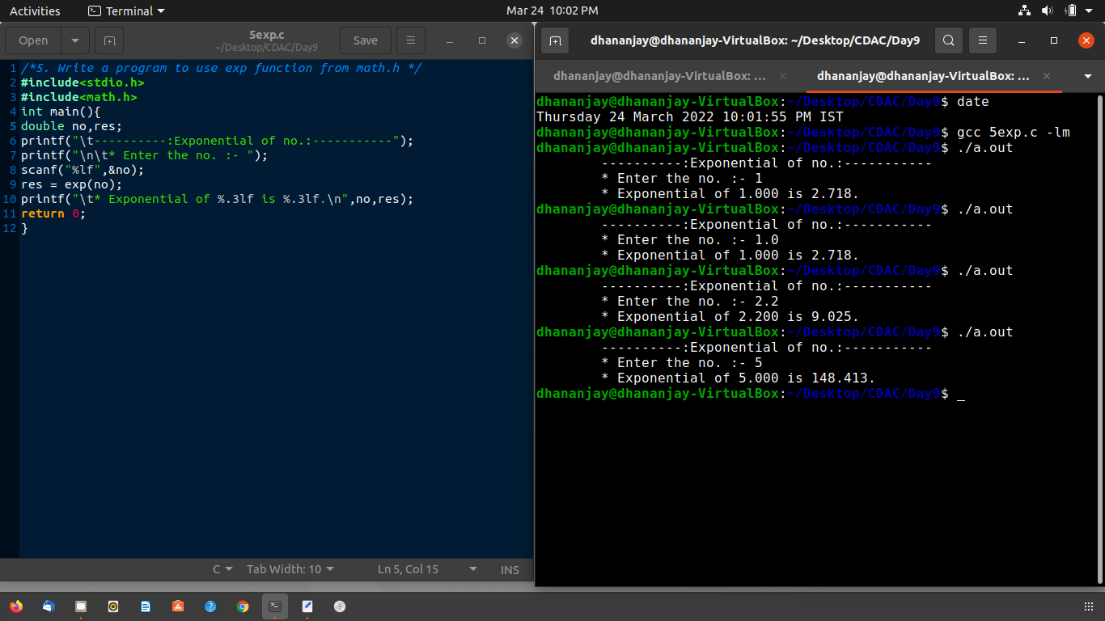

**Q6.**

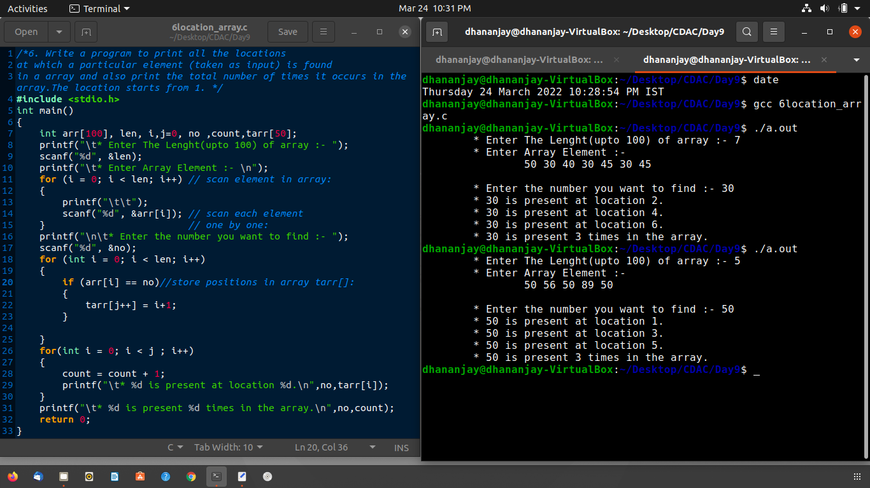

**Q7.**

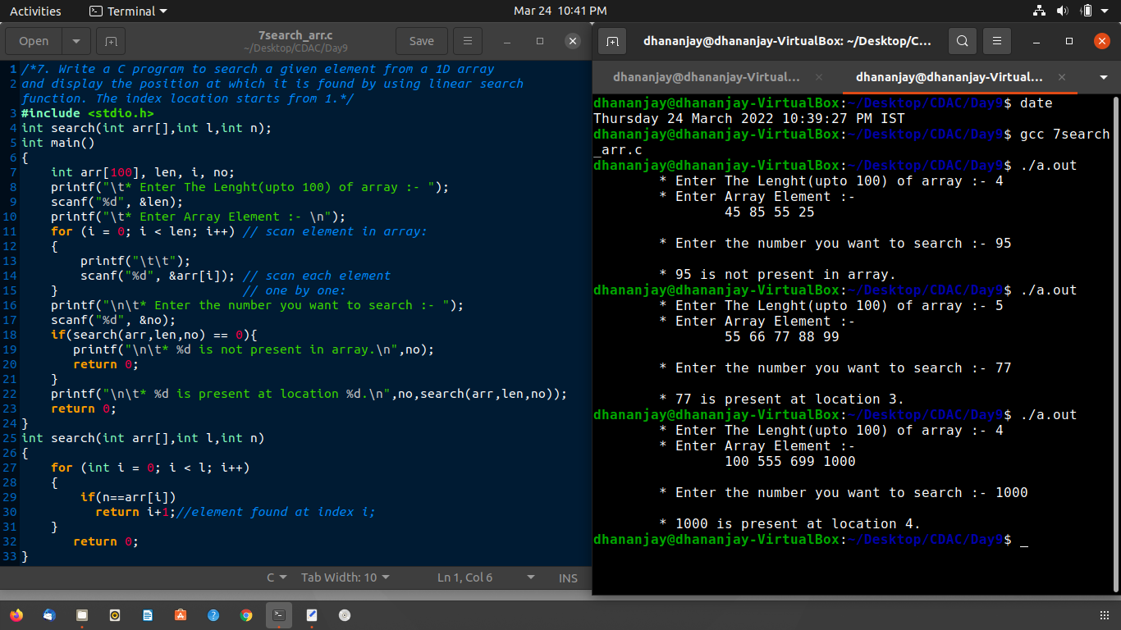

**Q8.**

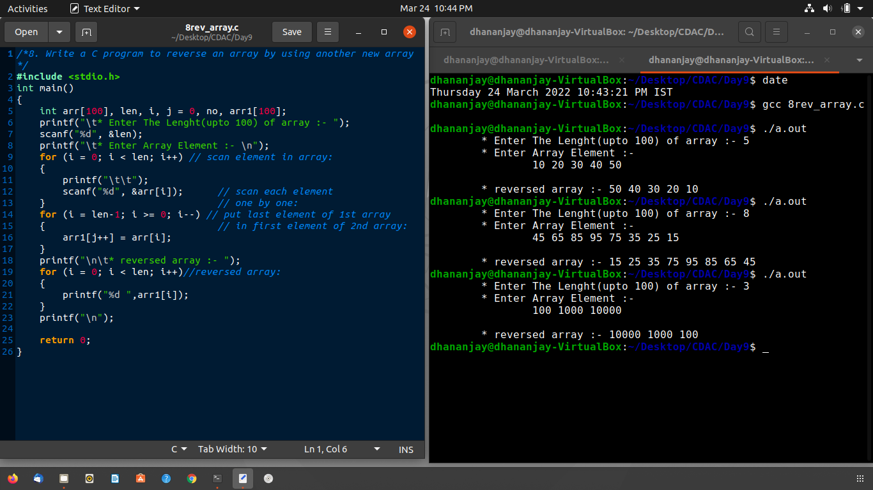

**Q9.**

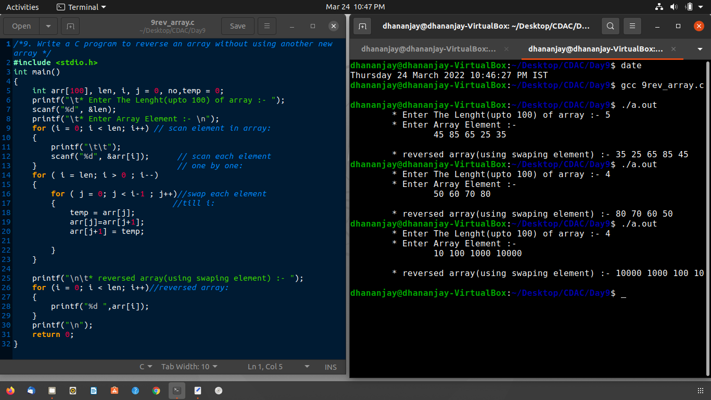

**Day10: 🡪structure Q1.**

/*1. Write a simple structure called student containing fields

(int id, char gender and char name[size]; Create a variable of this structure(ex: std1),

fill in the fields of this structure variable and

use a pointer to std1 which changes the member values for std1.*/

#include <string.h>

#include <stdio.h>

struct student

{

    int id;

    char gender;

    char name[30];

};

int main()

{

    struct student *ptr;

    struct student head;

    ptr = &head;

    char str[30];

    printf("\t* Fill the  data of student :\n");

    printf("\t* Enter The name of student :- ");

    scanf("%[^\n]s", str);

    strcpy(ptr->name, str);

    printf("\t* Enter The id of student :- ");

    scanf("%d", &ptr->id);

    printf("\t* Enter gender of student(M/F) :- ");

    scanf(" %c", &ptr->gender);

    printf("\n\t* Display information:- ");

    printf("\n\t* name of sudent :- %s", ptr->name);

    printf("\n\t* id of student :- %d", ptr->id);

    printf("\n\t* gender of student :- %c", ptr->gender);

    return 0;

}

**Output:**

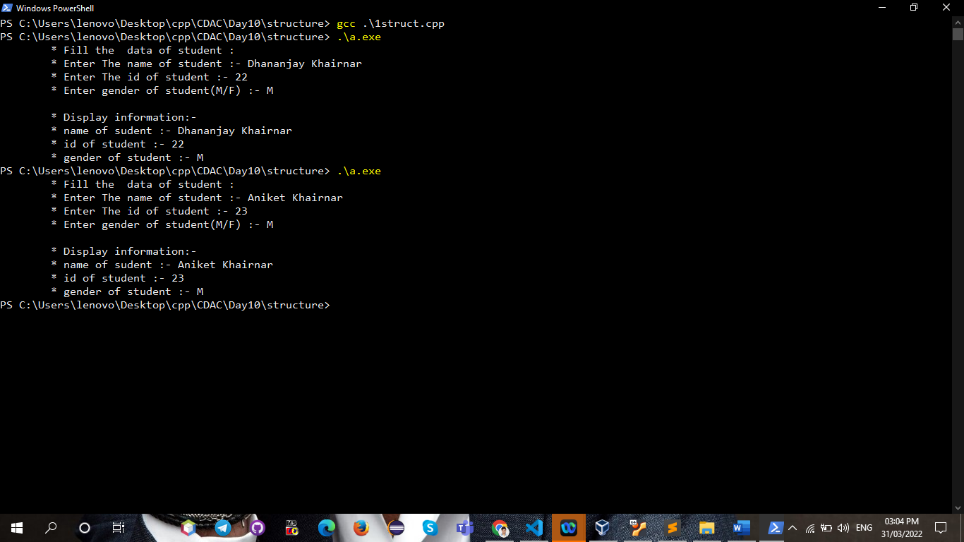

**Q2.**

/*2. Define a structure type struct personal that would contain person name, date of joining and salary using this structure to read this information of 5 people and print the same on screen */

#include<stdio.h>

#include"clean.h"

struct personal

{

    char date[10];

    float salary;

    char name[30];

}people[5];

int main(){

    printf("\t* Fill details of 5 people.\n");

    for (int i = 0; i < 5; i++){

        printf("\n\t* Person %d : ",i+1);

        printf("\n\t* Enter the name :- ");

**Output:**

        scanf("%[^\n]s",people[i].name);

        printf("\t* Enter the date of joining :- ");

        scanf("%s",people[i].date);

        printf("\t* Enter the salary :- ");

        scanf("%f",&people[i].salary);

        clean_stdin();

    }

    printf("\n\t*Show Details of all people : \n");

    for(int i = 0 ; i < 5 ; i++){

        printf("\n\t* Person %d : ",i+1);

        printf("\n\t* Name :- %s",people[i].name);

        printf("\n\t* Date of joining :- %s",people[i].date);

        printf("\n\t* salary :- %.2f\n",people[i].salary);

    }

return 0;

}

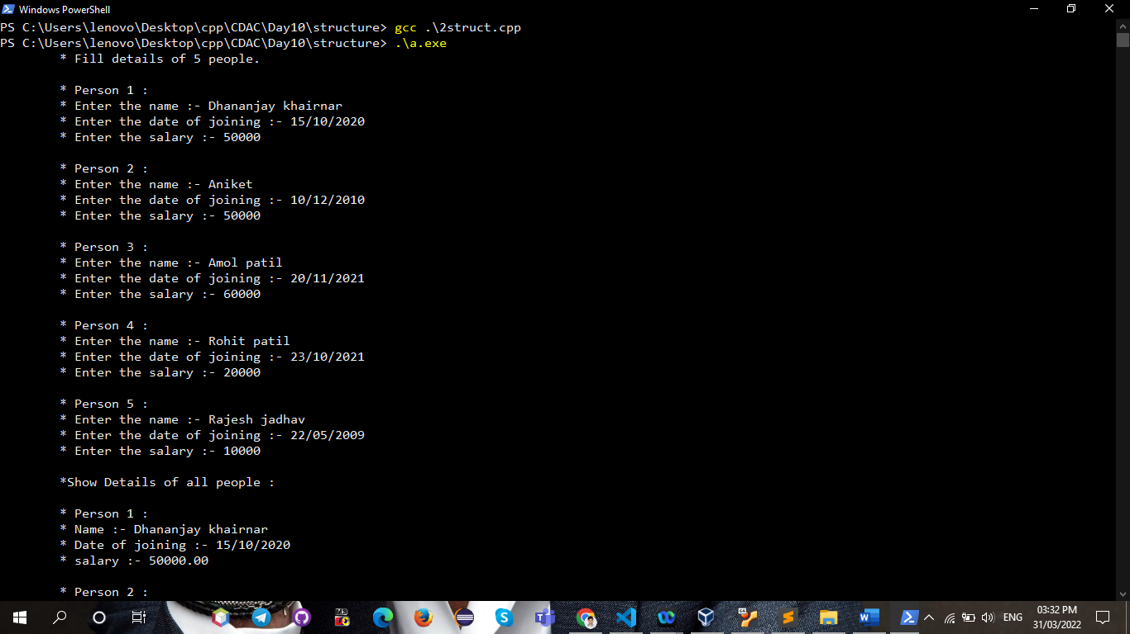

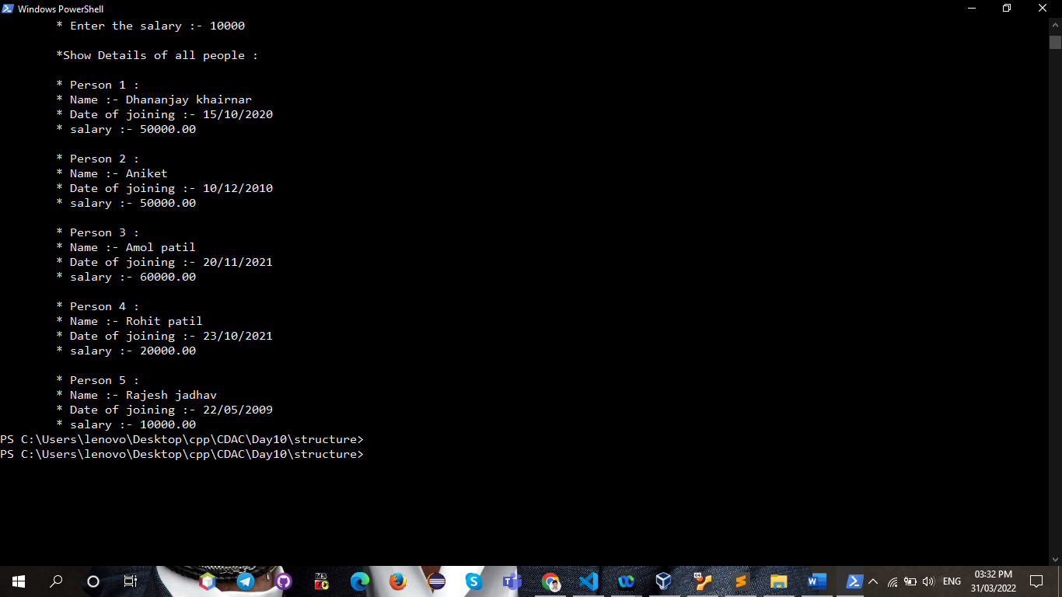

**Q3.**

/*3. Define structure data type called time_struct containing three member’s integer hour, integer

minute and integer second. Develop a program that would assign values to the individual

number and display the time in the following format: 16: 40:51 */

#include<stdio.h>

void time_format(struct time_struct *p);

struct time_struct

{

    int hour, minute, second;

};

int main(){

    struct time_struct time;

    struct time_struct *t = &time;

    printf("\n\t* Enter hour : ");

    scanf("%d",&time.hour);

    printf("\t* Enter minute : ");

    scanf("%d",&time.minute);

    printf("\t* Enter second : ");

    scanf("%d",&time.second);

    time_format(t);

return 0;

}

void time_format(struct time_struct *p)

{

    if(p->hour<24&&p->minute<60&&p->second<60){

    printf("\n\t* Time in format(hr: m: s) :-> ");

    printf("%d: %d: %d",p->hour,p->minute,p->second);

    }

    else

    printf("\t* Wrong time :");

}

**output:**

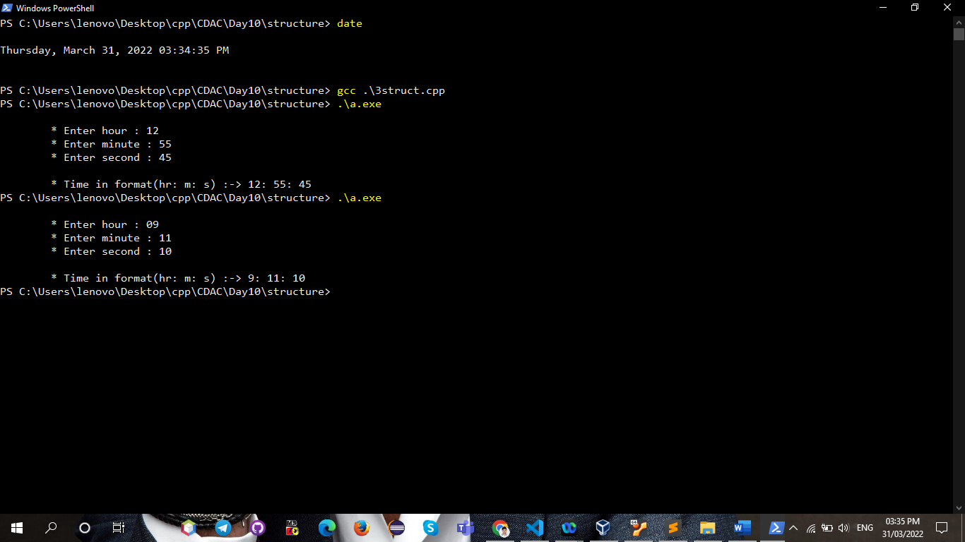

**Q4.**

/* Using cricket, declare an array player with 50 elements and write a C program to read the

information about all the 50 players and print team-wise list containing names of players with

their batting average. */

#include<stdio.h>

#include "clean.h"

void setdata(struct cricket *p);

void getdata(struct cricket *p);

struct cricket

{

    char p_name[20],t_name[20];

    float b_avr;

}player[50];

int main(){

    printf("\n\t* Fill The information :- ");

    for(int i = 0 ; i < 50 ; i++){

        printf("\n\t* Player %d :\n",i+1);

        setdata(&player[i]);

    }

    printf("\n\t* Display Information : \n");

    for (int i = 0; i < 50; i++)

    {

        printf("\n\t* Player %d",i+1);

        getdata(&player[i]);

        printf("\n");

    }

return 0;

}

void setdata(struct cricket *p)

{

    printf("\t* Enter Name of Player : ");

    scanf("%[^\n]s",p->p_name);

    printf("\t* Enter Team Name : ");

    scanf("%s",p->t_name);

    printf("\t* Enter Average : ");

    scanf("%f",&p->b_avr);

    clean_stdin();

}

void getdata(struct cricket *p)

{

    printf("\t* Name of Player :- %s   ",p->p_name);

    printf("\t* Team :- %s",p->t_name);

    printf("\t* Batting Average :- %.2f",p->b_avr);

}

**Q5.**

/* 5. Design a structure student_record to contain name, branch and total marks obtained.

Develop a program to read data for 10 students in a class and print the */

#include <stdio.h>

#include "clean.h"

void getdata(struct student_record *ptr);

void setdata(struct student_record *ptr);

struct student_record

{

    char name[30];

    char branch[10];

    int marks;

} stud[10];

int main()

{

    printf("\t* Fill Details of Student :\n");

    for (int i = 0; i < 10; i++)

    {

        printf("\n\t* Student %d :\n",i+1);

        setdata(&stud[i]);

    }

    for (int i = 0; i < 10; i++)

    {

        printf("\n\t* Student %d :",i+1);

        getdata(&stud[i]);

    }

    return 0;

}

void getdata(struct student_record *ptr)

{

    printf("\n\t* Name : %s", ptr->name);

    printf("\n\t* Branch : %s", ptr->branch);

    printf("\n\t* Total Marks : %d\n", ptr->marks);

}

void setdata(struct student_record *ptr)

{

    printf("\t* Enter The Name :- ");

    scanf("%[^\n]s", ptr->name);

    printf("\t* Enter The Branch :- ");

    scanf("%s", ptr->branch);

    printf("\t* Enter The Marks :- ");

    scanf("%d", &ptr->marks);

    clean_stdin();

}

**Output:-**

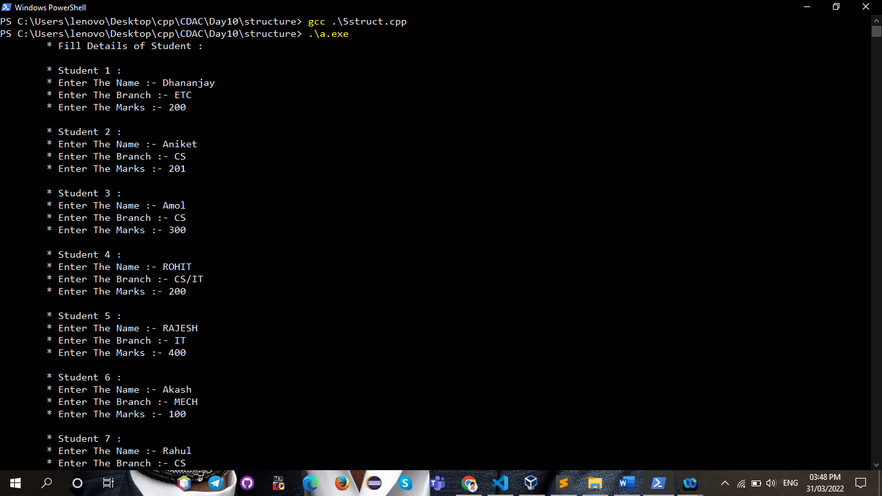

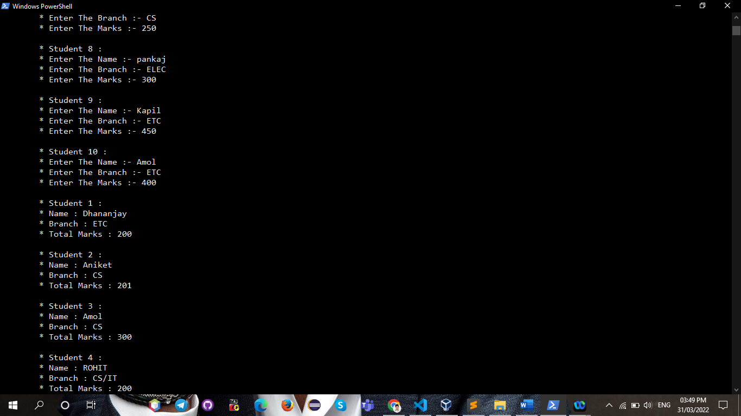

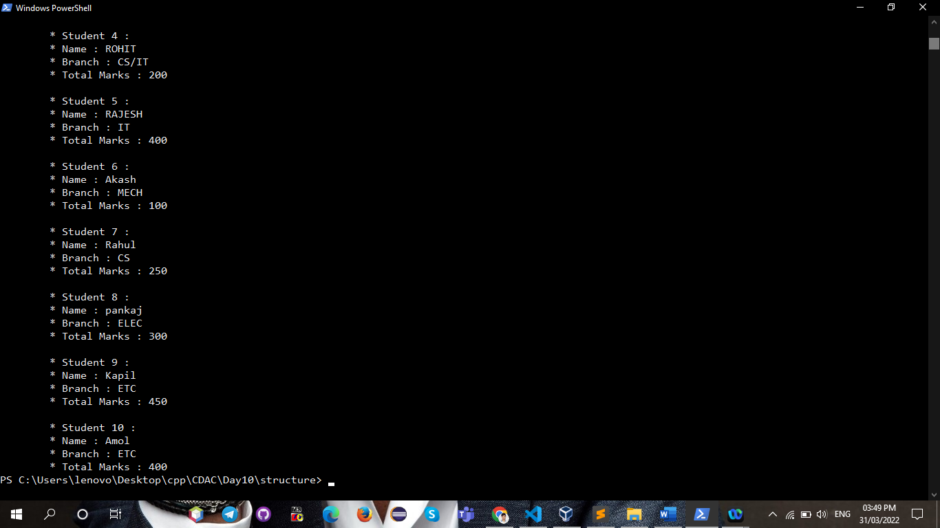

**🡪File_handling: Q1.**

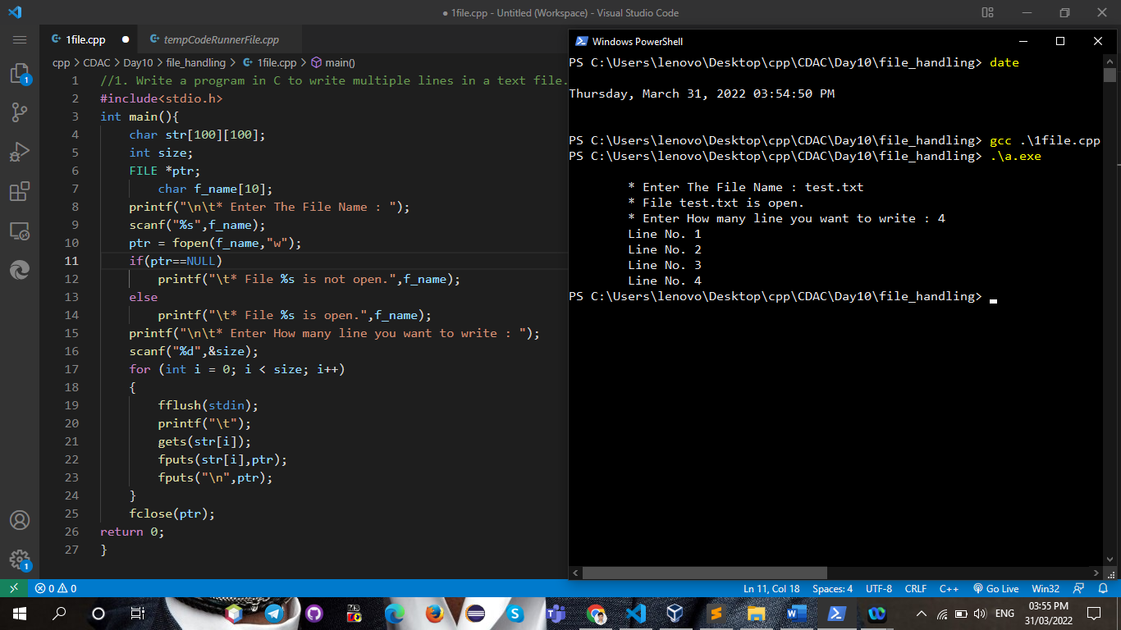

**output file:**

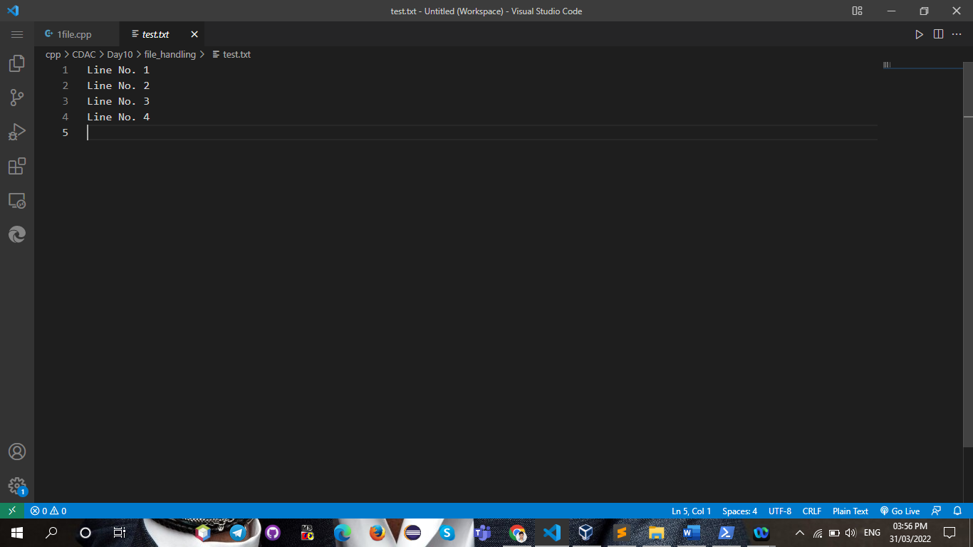

**Q2.**

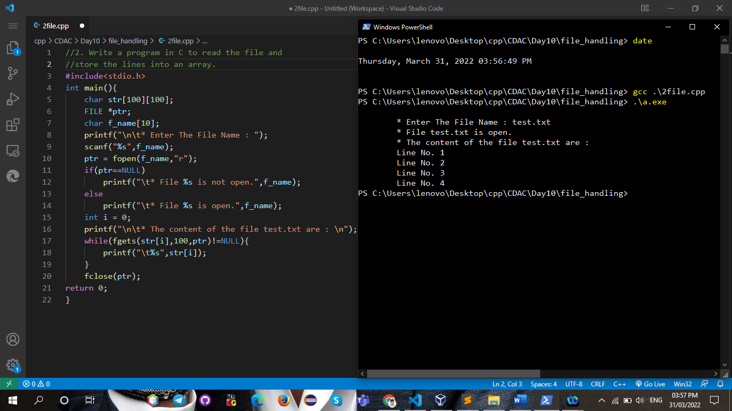

**Q3.**

// 3. Write a program in C to count a number of words and characters in a file.

#include <stdio.h>

int main()

{

    char c ;

    FILE *ptr;

    char f_name[10],str[100];

    int count = 0, word = 0;

    printf("\n\t* Enter The File Name : ");

    scanf("%s", f_name);

    ptr = fopen(f_name, "r");

    if (ptr == NULL)

    {

        printf("\t* File %s is not open.",f_name);

    }

    else

    {

        printf("\t* File %s is open.",f_name);

    }

    int i = 0;

    printf("\n\t* The content of the file test.txt are : \n");

    while (fgets(str[i], 100, ptr) != NULL)

    {

        printf("\t%s", str[i]);

    }

    fclose(ptr);

    ptr = fopen("test.txt", "r");

    while (1)

    {

        c = fgetc(ptr);

        if (feof(ptr))

        {

            break;

        }

        if (c == ' ' || c == '\n')

            word = word + 1;

        if (c != '\n')

            count = count + 1;

        if (c == ' ')

            count = count - 1;

    }

    printf("\n\t* The number of words in the file : %d", word);

    printf("\n\t* The number of characters in the file : %d", count);

    return 0;

}

**output:-**

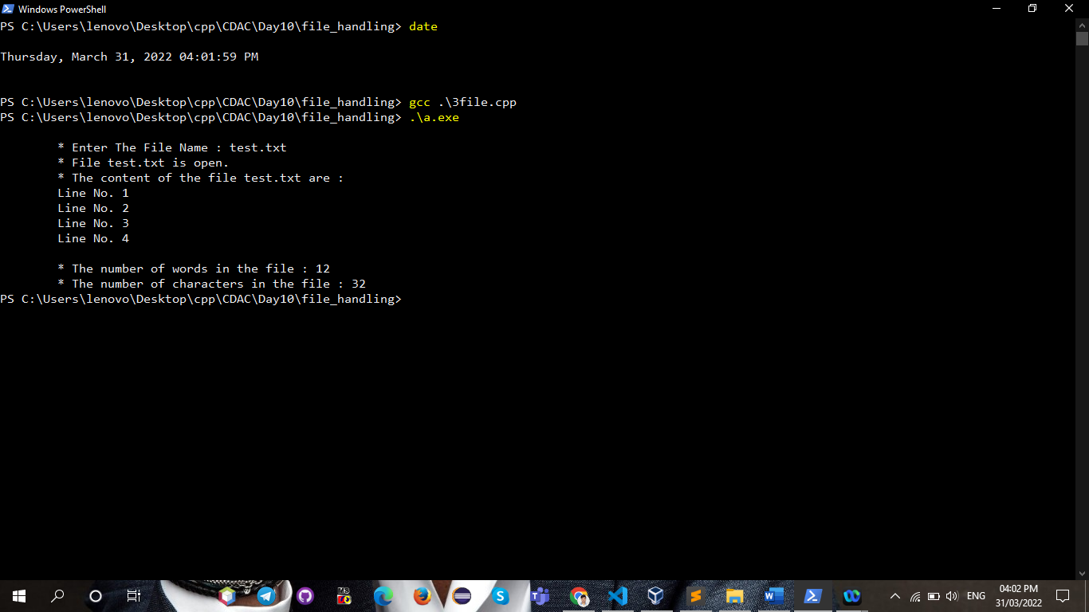

**Q4.**

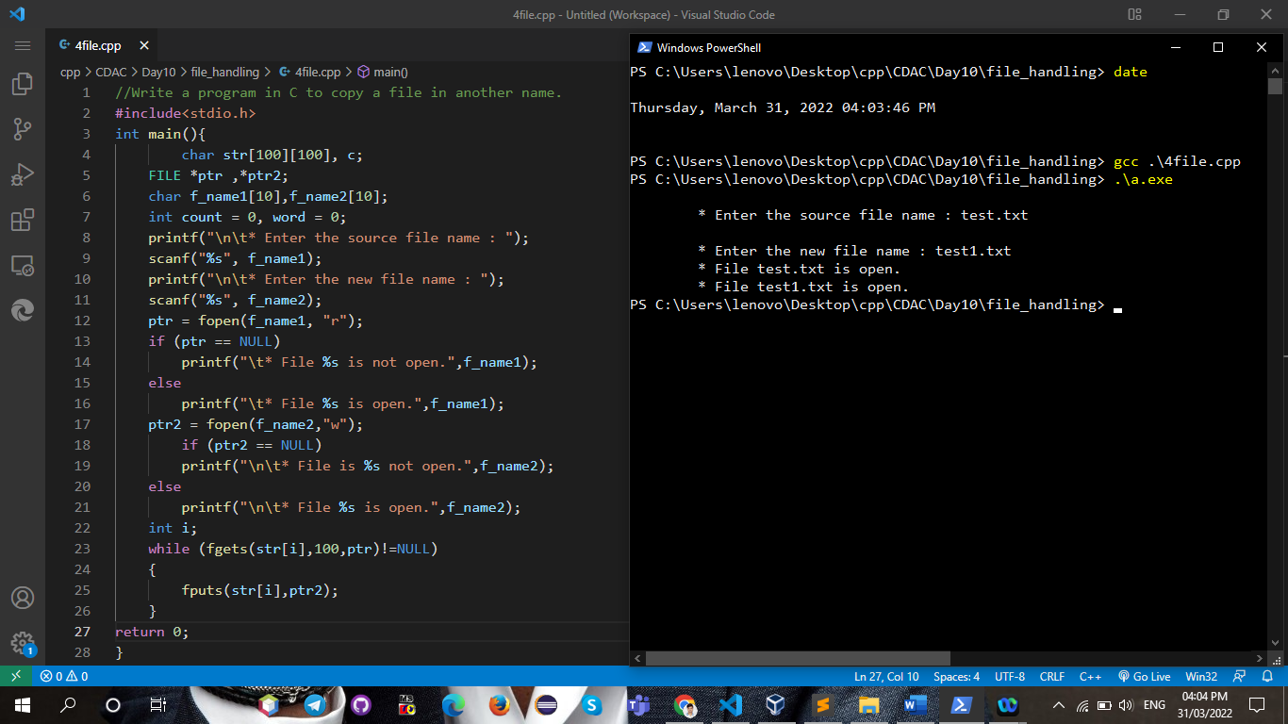

**output files:**

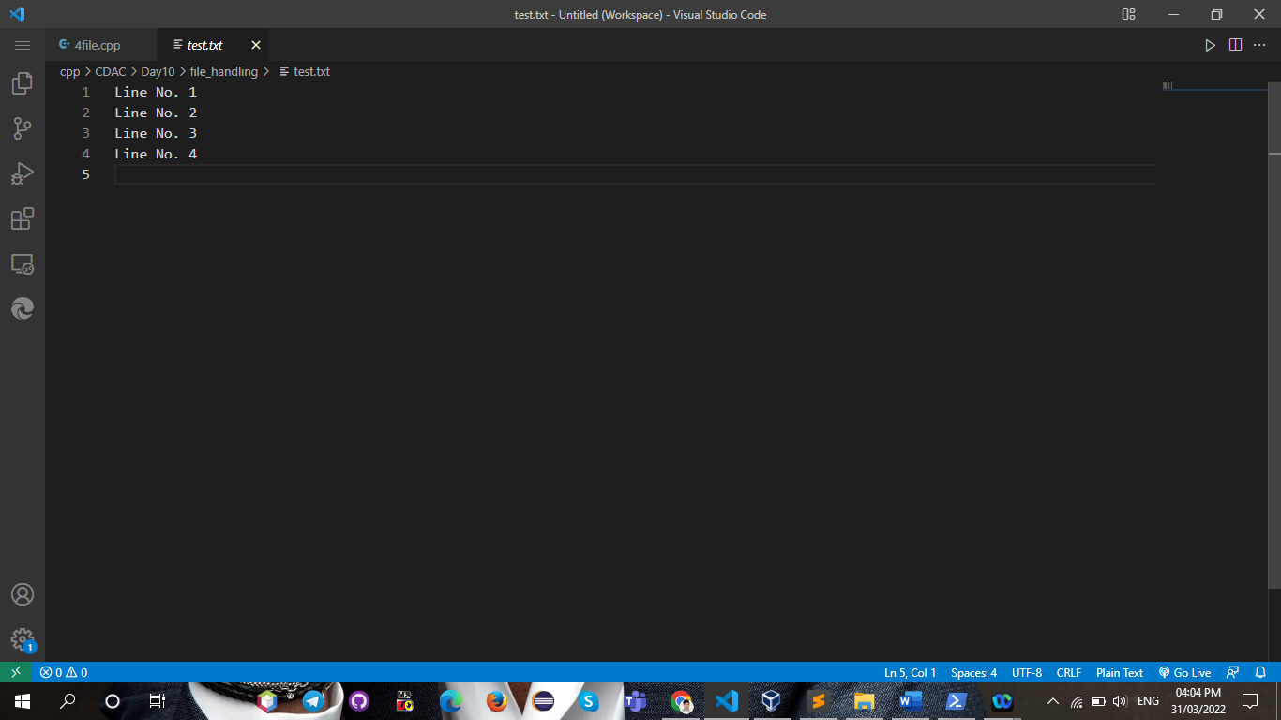

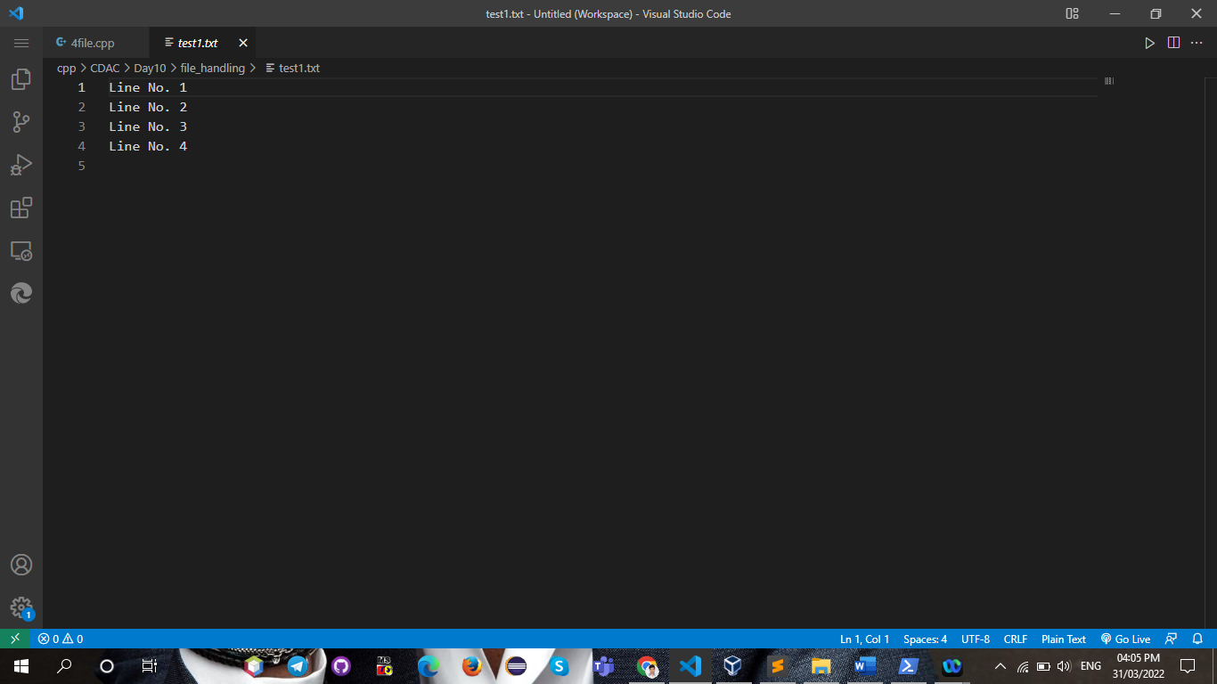

**Q5.**

5. Write a program in C to replace a specific line with another text in a file.

#include<stdio.h>

int main(){

    char str[100][100];

    int size;

    FILE *ptr,*ptr2;

        char f_name[10];

    printf("\n\t* Enter The File Name : ");

    scanf("%s",f_name);

    ptr = fopen(f_name,"r");

    if(ptr==NULL)

    {

        printf("\t* File %s is not open.",f_name);

    }

    else

    {

        printf("\t* File %s is open.",f_name);

    }

    printf("\n\t* Enter the number of line which is you want to replace : ");

    scanf("%d",&size);

    rewind(ptr);

    ptr2 = fopen(f_name,"w");

     while (c != EOF)

    {

        if (c == 'n')

        {

            temp++;

        }

        till the line to be deleted comes,copy the content to other

        if (temp != delete_line)

        {

            putc(c, fileptr2);

        }

        else

        {

            while ((c = getc(fileptr1)) != 'n')

            {

            }

            read and skip the line ask for new text

            printf("Enter new text");

            flush the input stream

            fflush(stdin);

            putc('n', fileptr2);

            put 'n' in new file

            while ((c = getchar()) != 'n')

                putc(c, fileptr2);

            take the data from user and place it in new file

            fputs("n", fileptr2);

            temp++;

        }

    for (int i = 0; i <= size; i++)

    {

        fflush(stdin);

        if(i == size){

        printf("\t");

        gets(str[i]);

        fputs(str[i],ptr);

        }

    }

    fclose(ptr);

return 0;

}

**🡪** **Preprocessor directives**

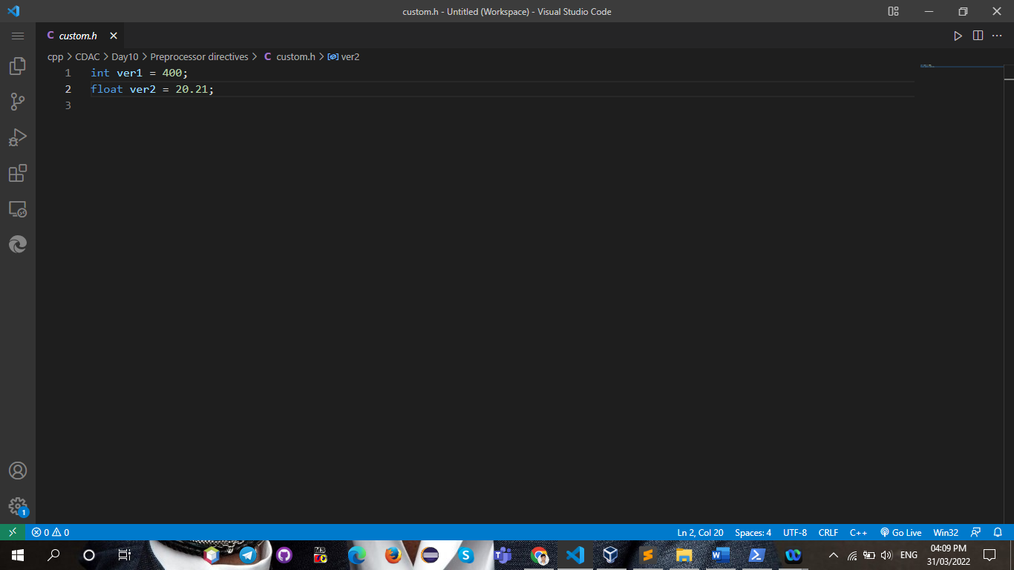

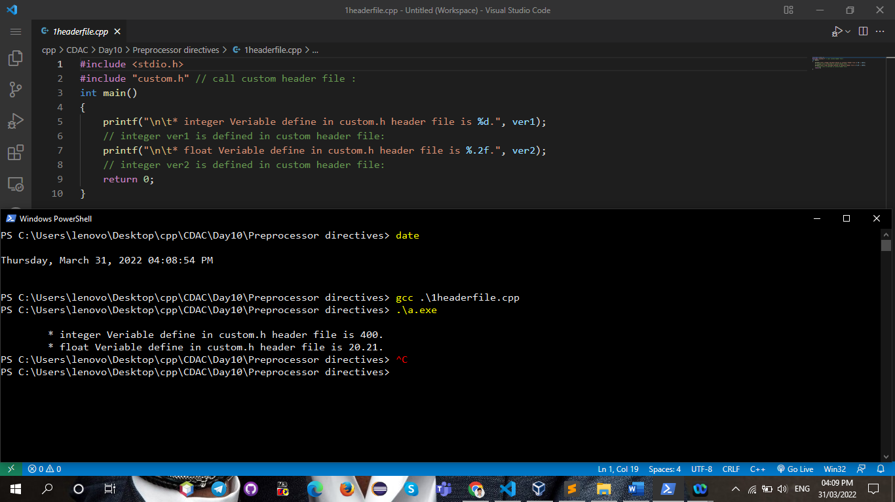

**Q2.**

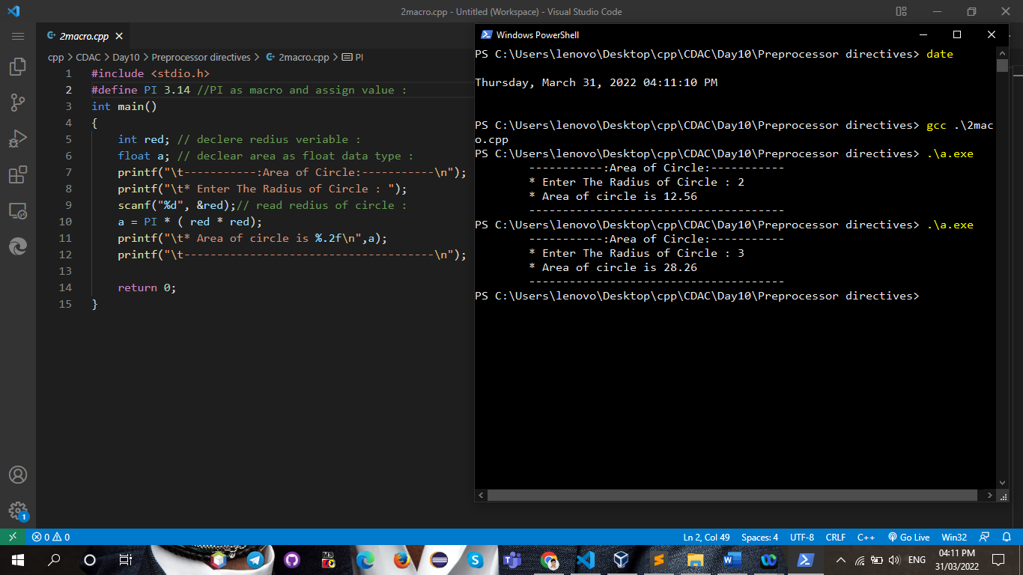

**Q3.**

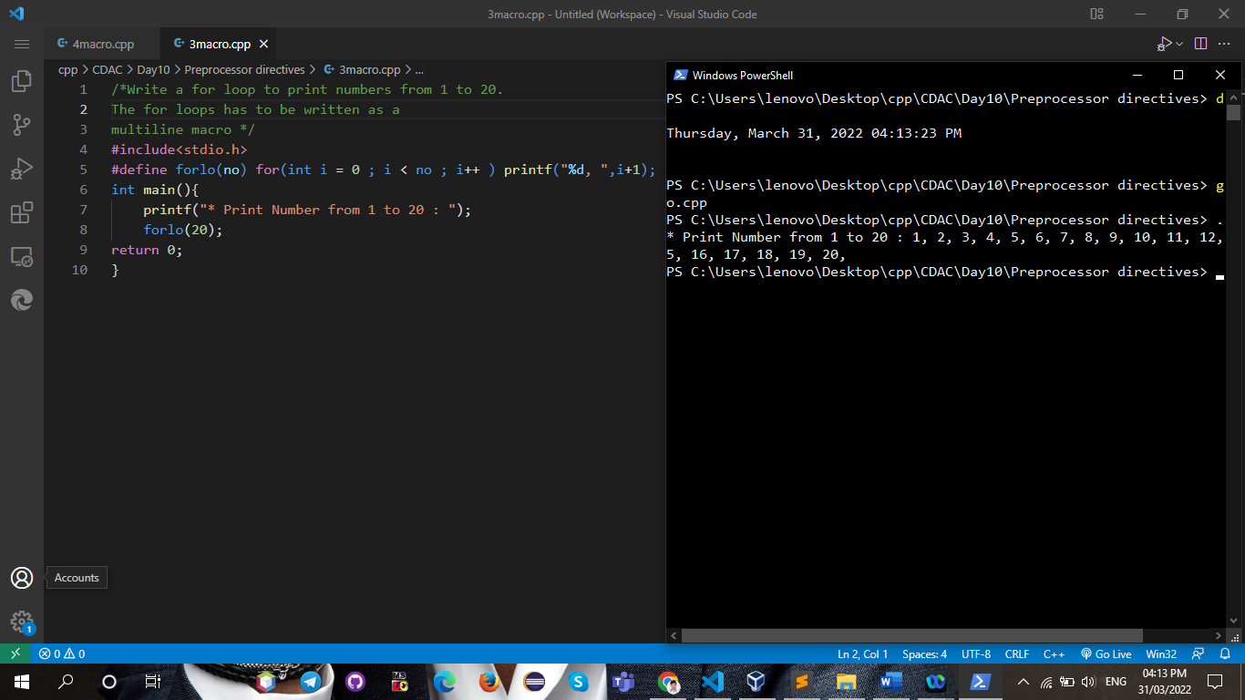

**Q4.**

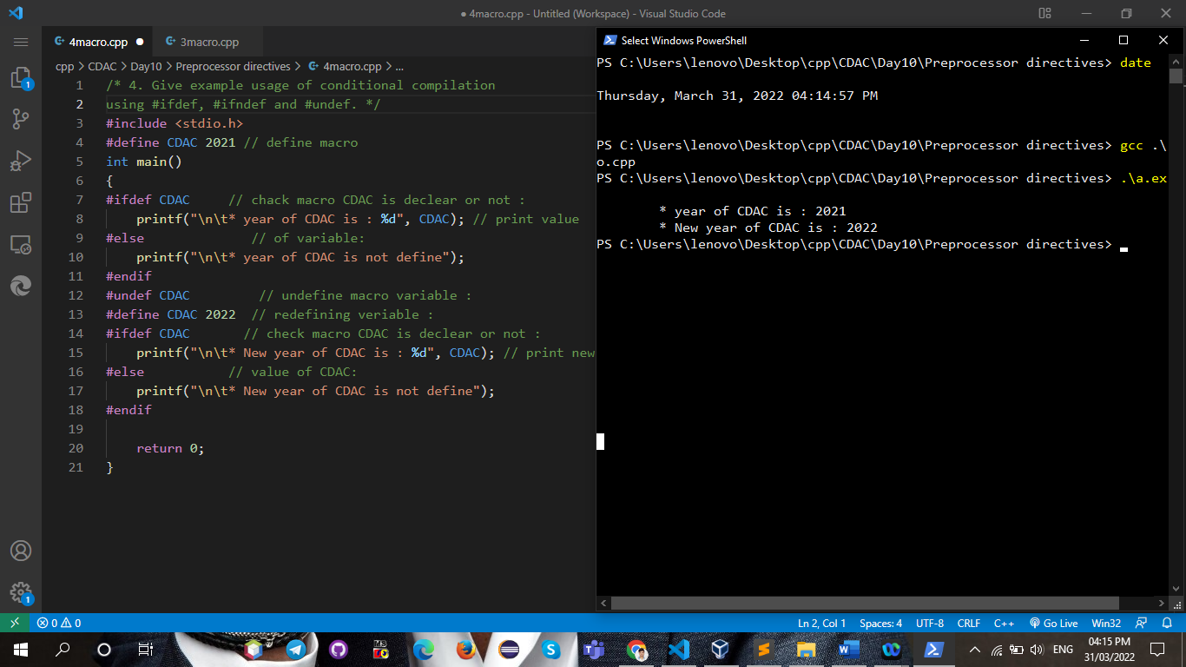

**Q5.**

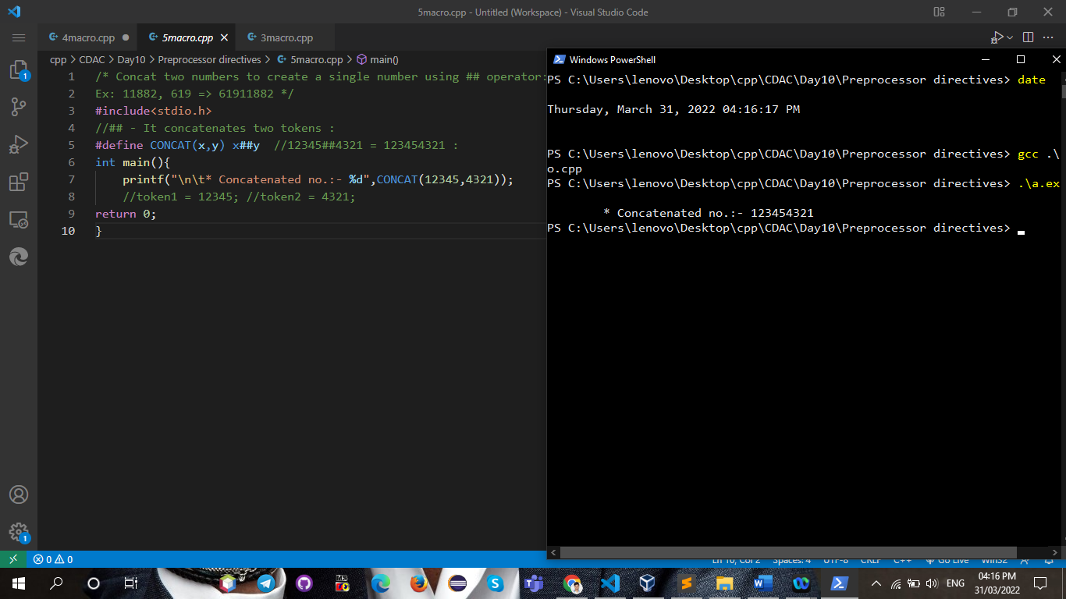

**🡪storage classes:-**

**Q1.**

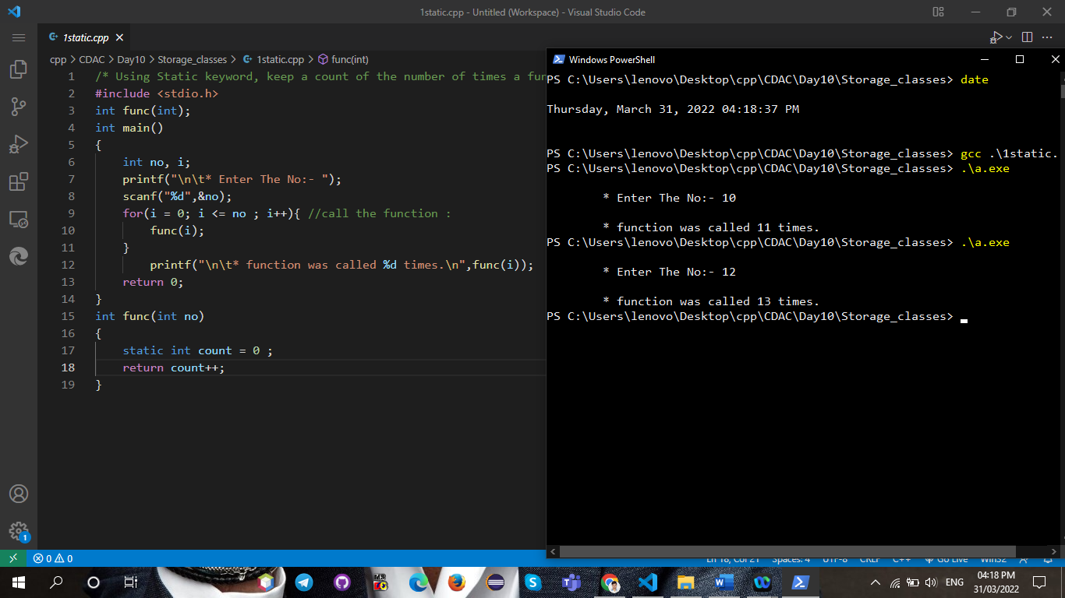

**Q2.**

